 Analytical Continuity between one and Zero

Shaimaa said soltan1

1 Computer Engineer, Toronto, Canada

Correspondence: Shaimaa Soltan, 3050 Constitution Blvd, Mississauga, ON., L4Y 3X1 , Canada. Tel: 1-647-801-6063 E-mail: shaimaasultan@hotmail.com

---------------------------------------------------------------------------------------------------------------------------------

**Suggested Reviewers** (Optional)

Please suggest 3-5 reviewers for this article. We may select reviewers from the list below in case we have no appropriate reviewers for this topic.

|  |  |
| --- | --- |
| Name: | E-mail: |
| Affiliation: | |

|  |  |
| --- | --- |
| Name: | E-mail: |
| Affiliation: | |

|  |  |
| --- | --- |
| Name: | E-mail: |
| Affiliation: | |

|  |  |
| --- | --- |
| Name: | E-mail: |
| Affiliation: | |

|  |  |
| --- | --- |
| Name: | E-mail: |
| Affiliation: | |

Analytical Continuity between one and Zero

**Abstract**

This paper will explain the reasoning for Analytical discontinuity in complex plane between values [0,1].

And getting a simpler formula that handle this discontinuity between [0,1]. And use this formula to give a proof for nontrivial Zeros at Re (0.5).

Finally, we will use this formula to find the sum of some infinite series.

**Keywords:** zeta function, Riemann hypothesis, complex plane, none-trivial zeros, critical strip, gamma function

**1. Introduction**

Understanding the reasoning behind Riemann hypothesis will give us better understanding for number distributions. In this paper we will cover a huge part of this number distributions. We will give a general formula for number distributions and graphs and how numbers are visualized on complex plane using this formula. Then we will explain why we have Zero at X = 0.5 and the reasoning behind this distribution

π 🡪 in radian = 3.1415926535897932384626433832795 ;

π 🡪 in Degrees = 180

In Degrees 🡪 ; In Radian 🡪

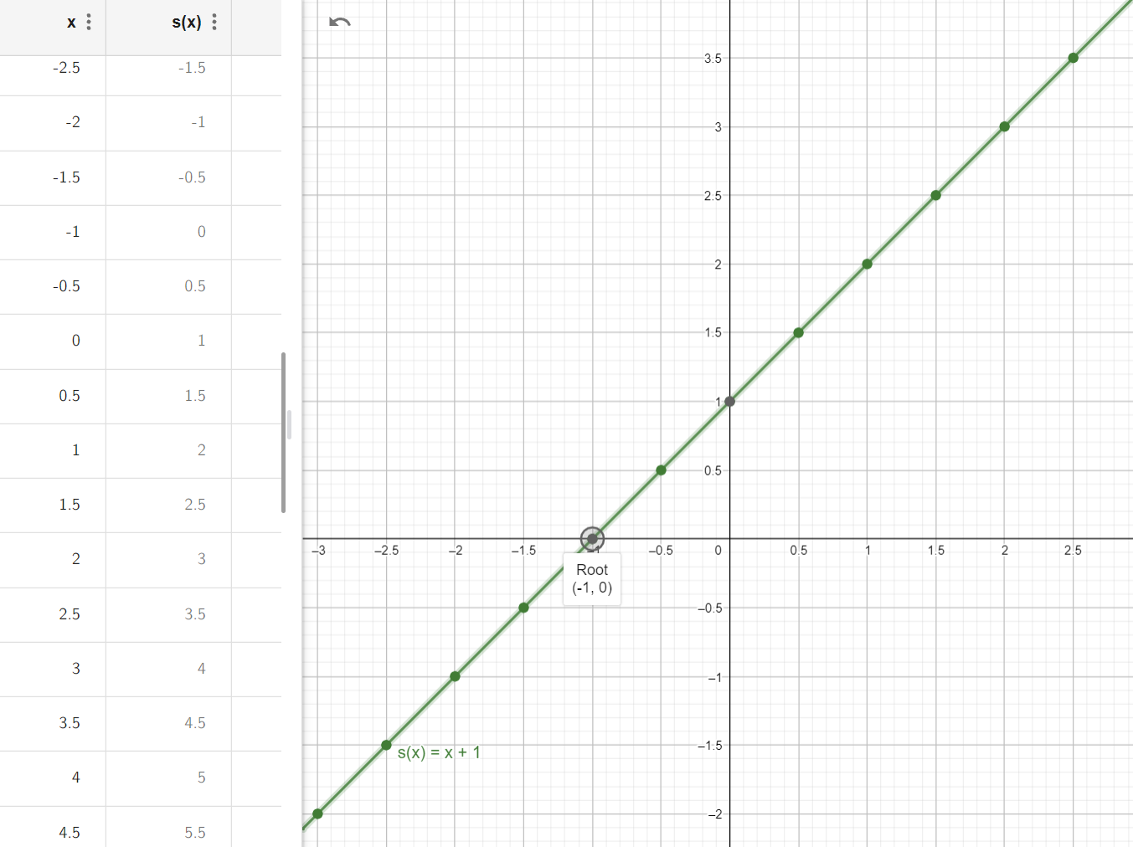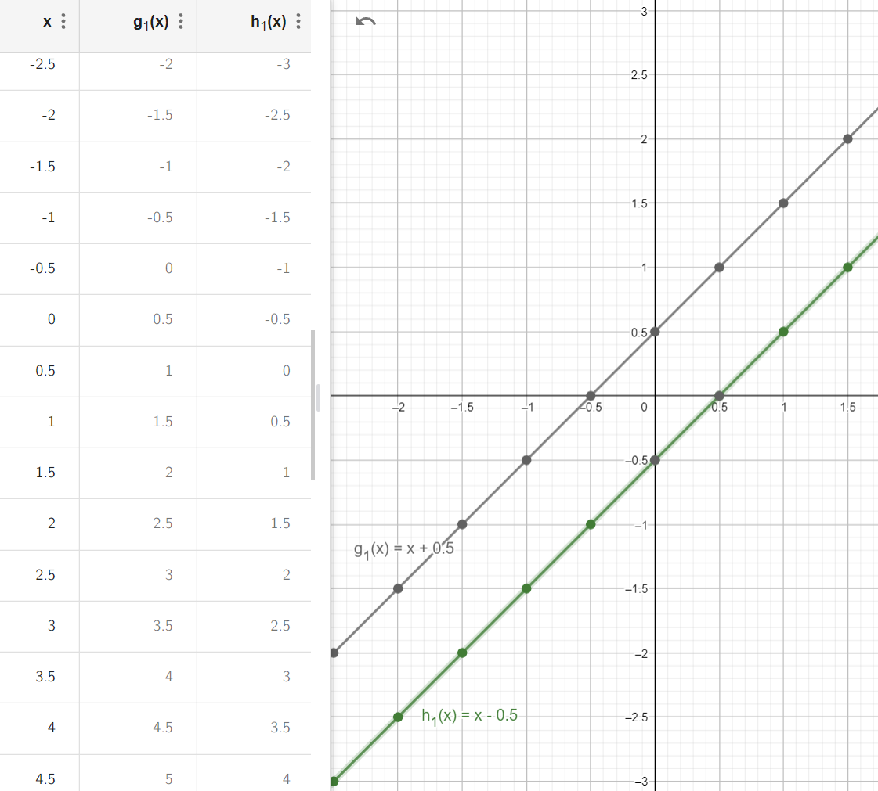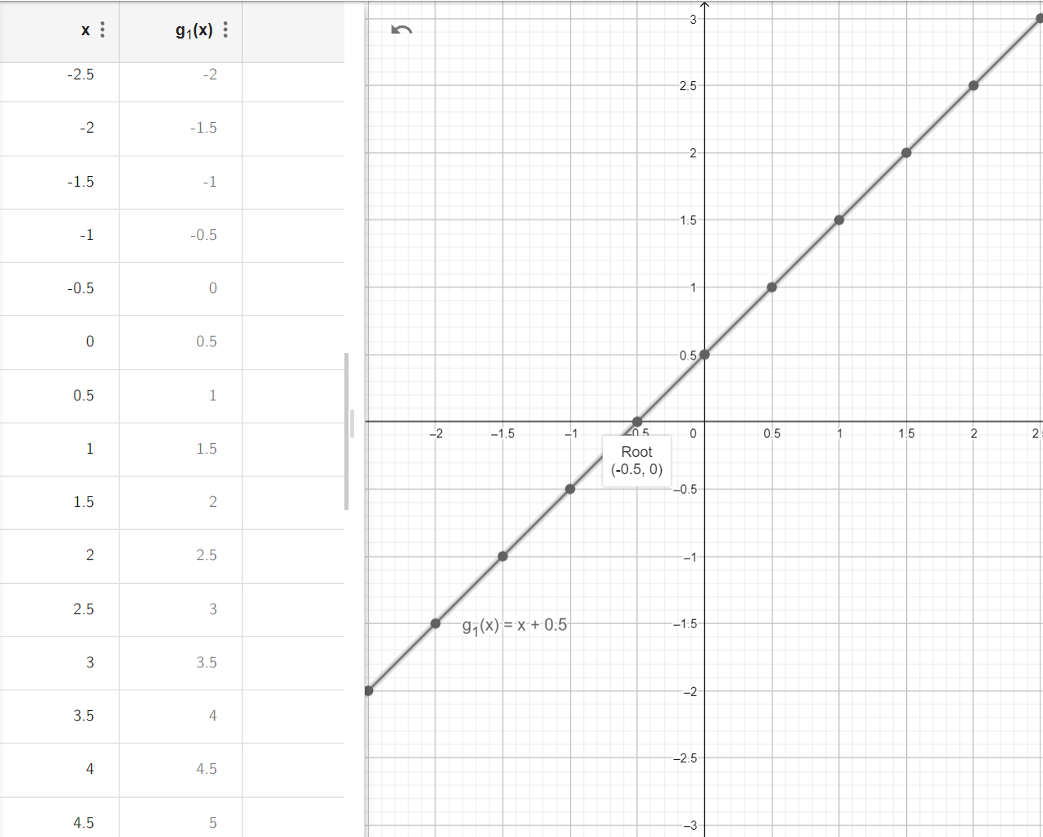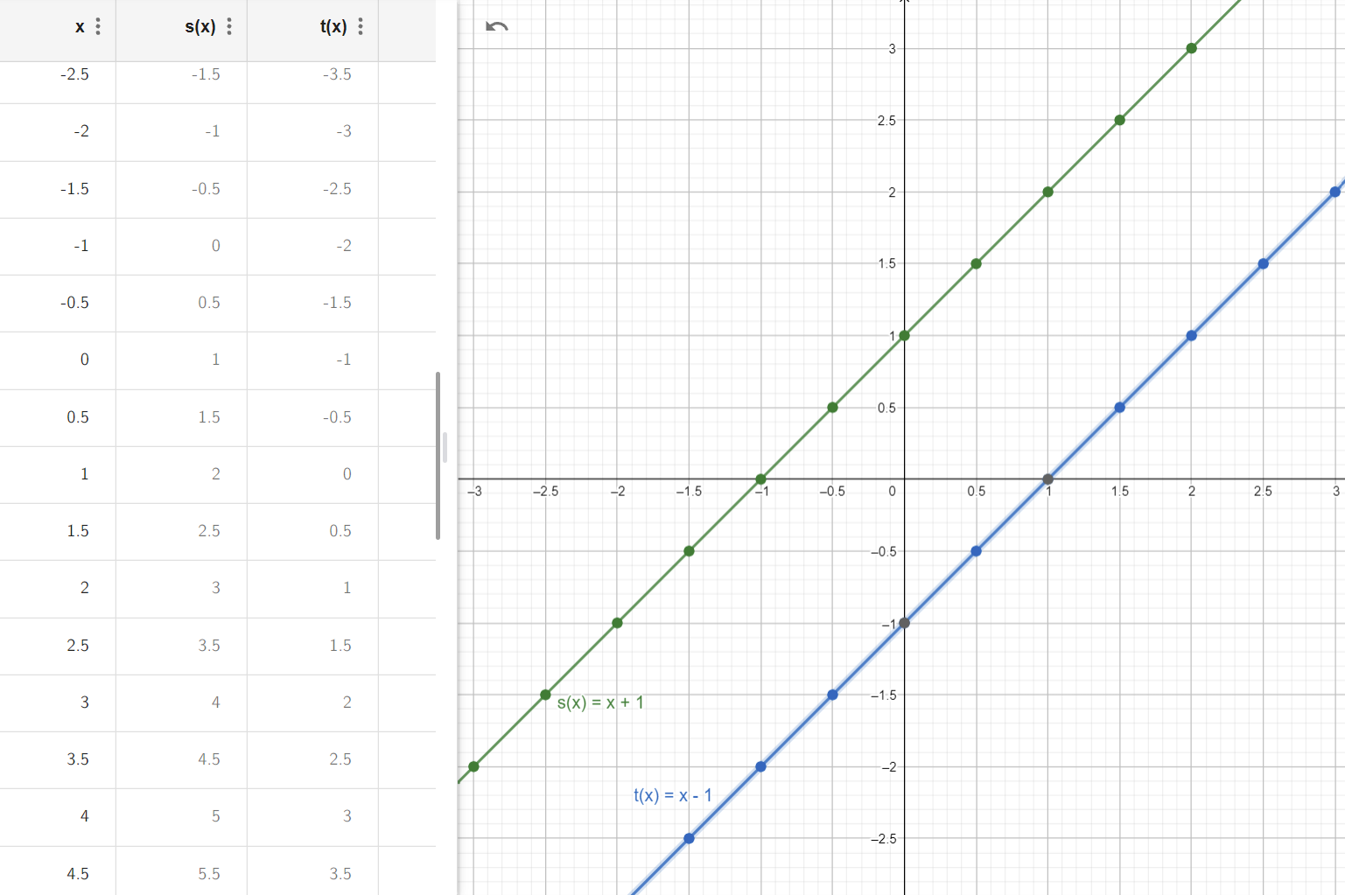

1. Multiply by (360) 🡪



Then ( -0.5 = 180 = π) and (0.5 = 540 = 360 +180 = 3 π)

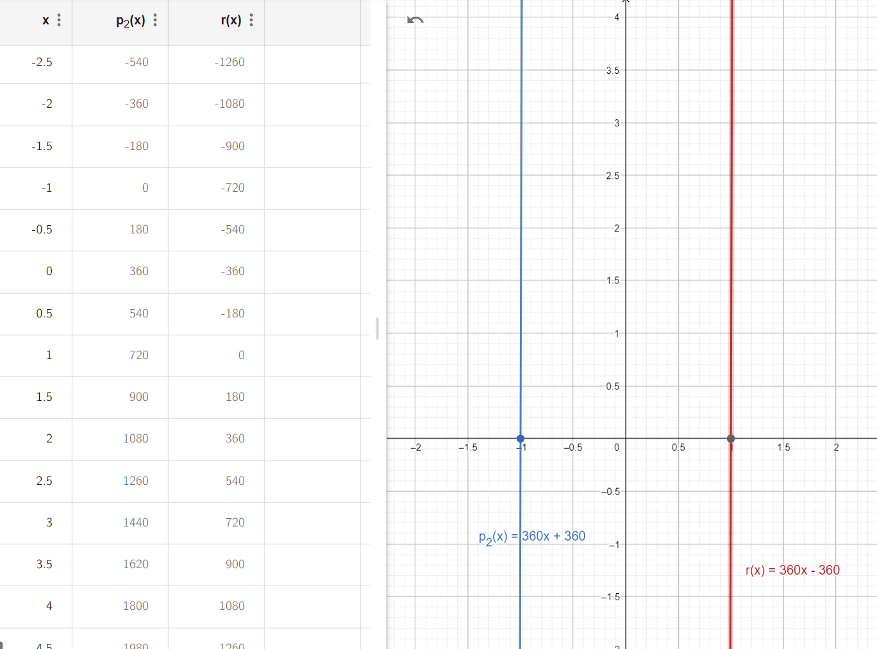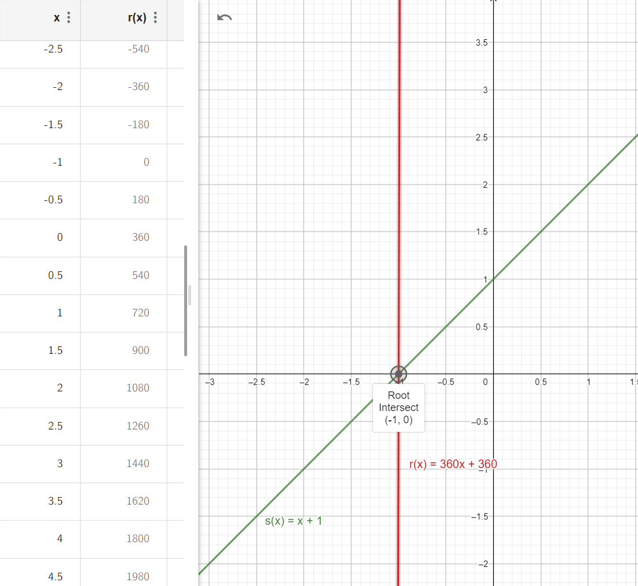

1. Multiply by (360) 🡪

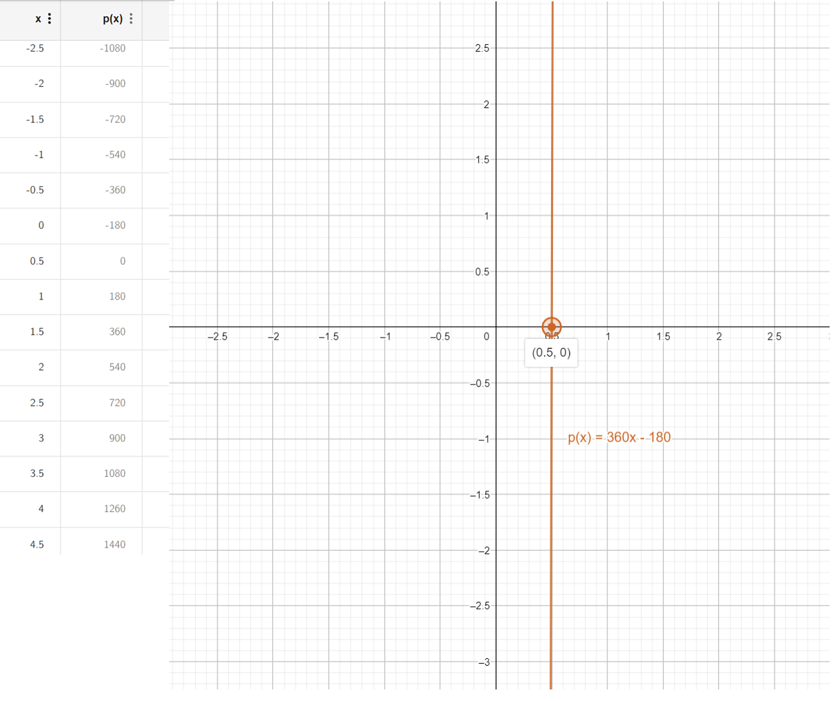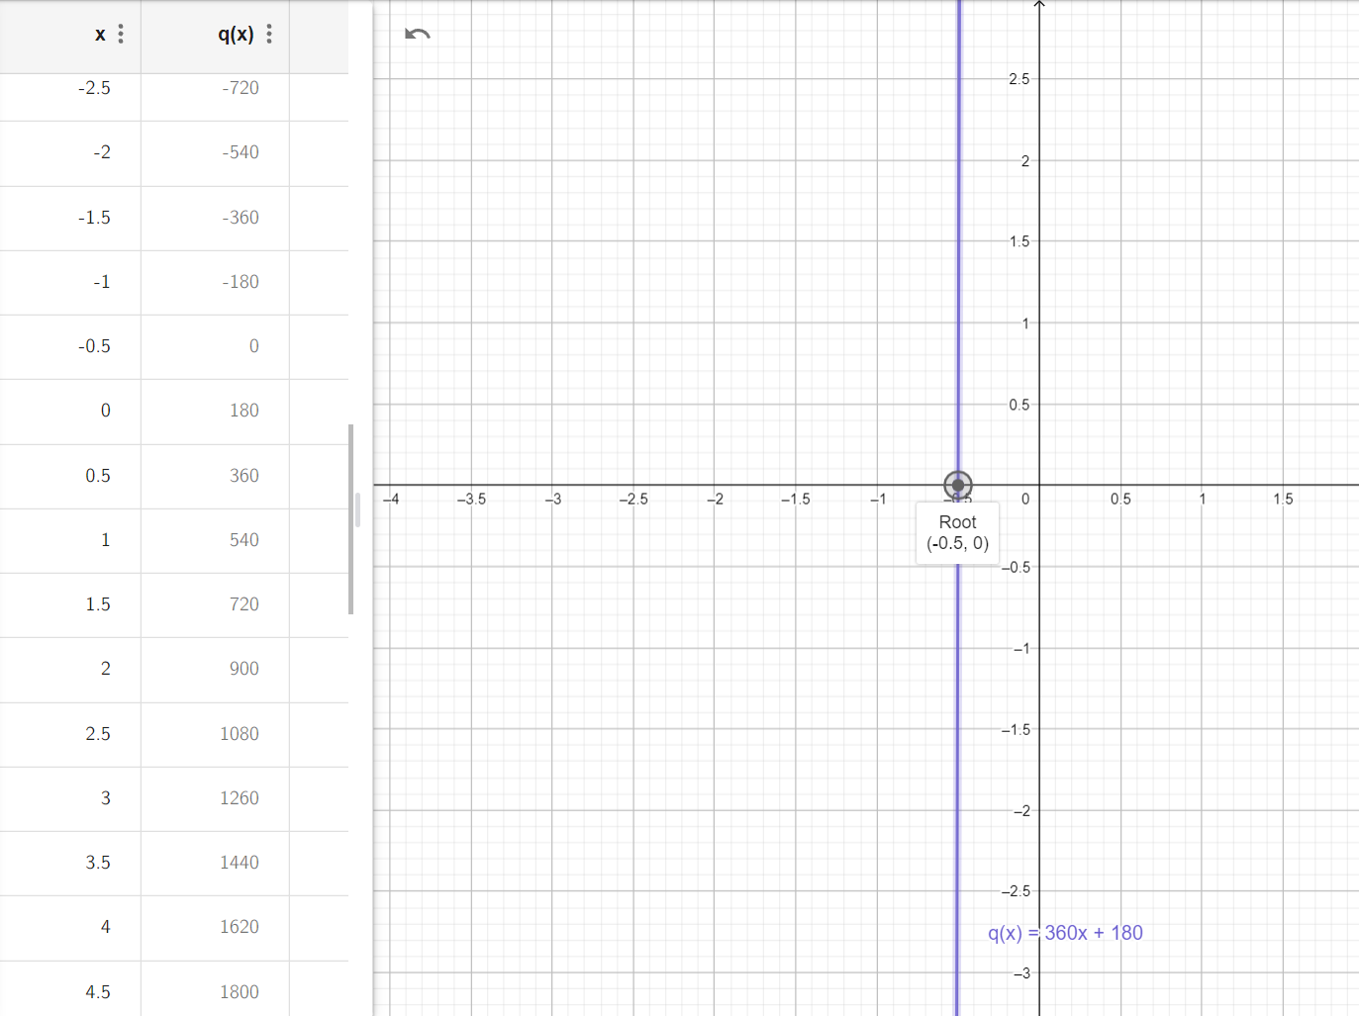

1. 🡪 one degree difference and Y =0 when X = 1/360

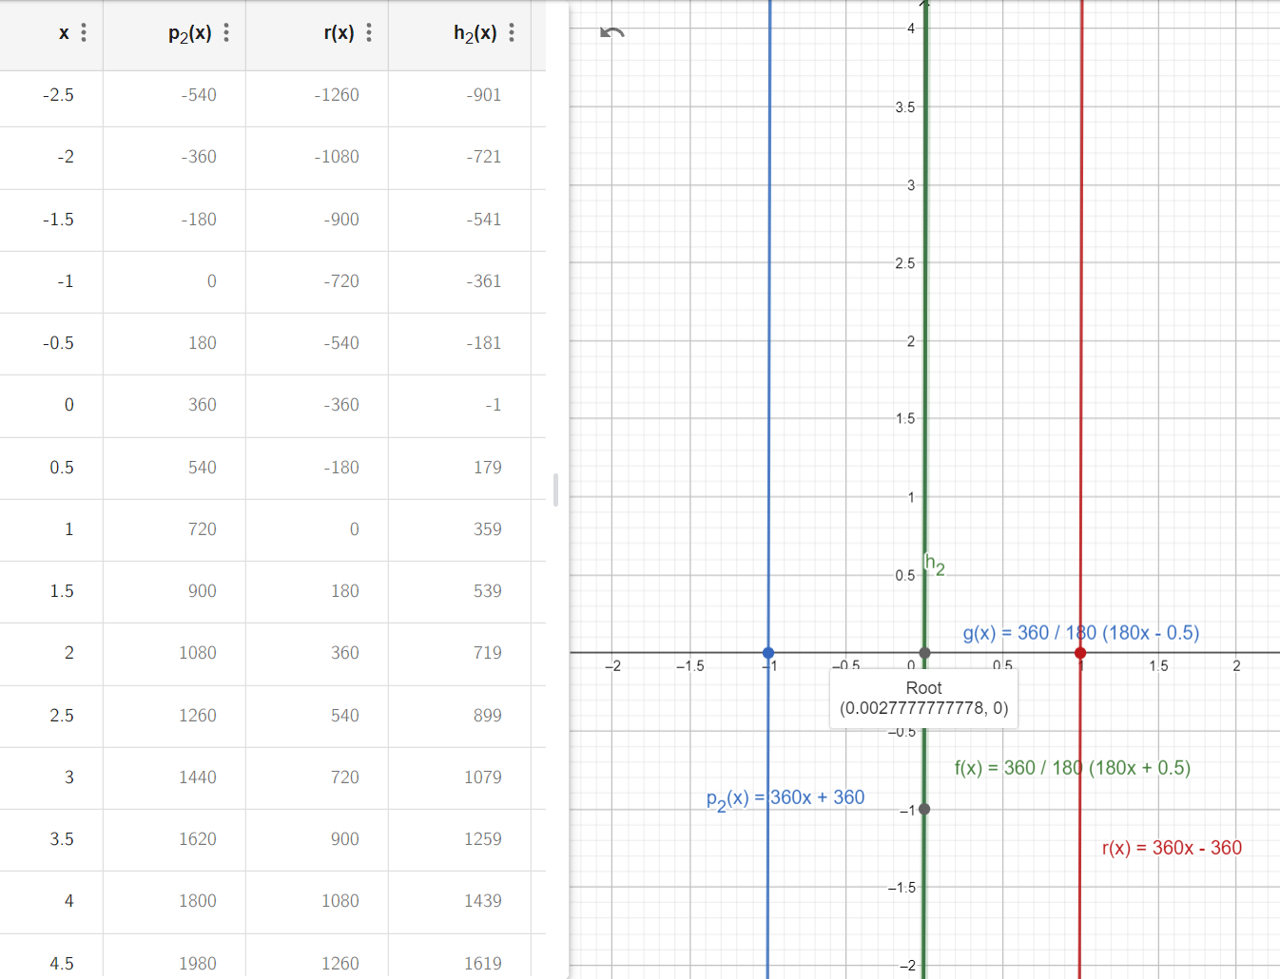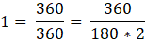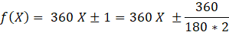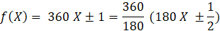

When X = 1/360



1. 🡪 one degree difference and Y =0 when X = 1/360

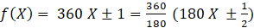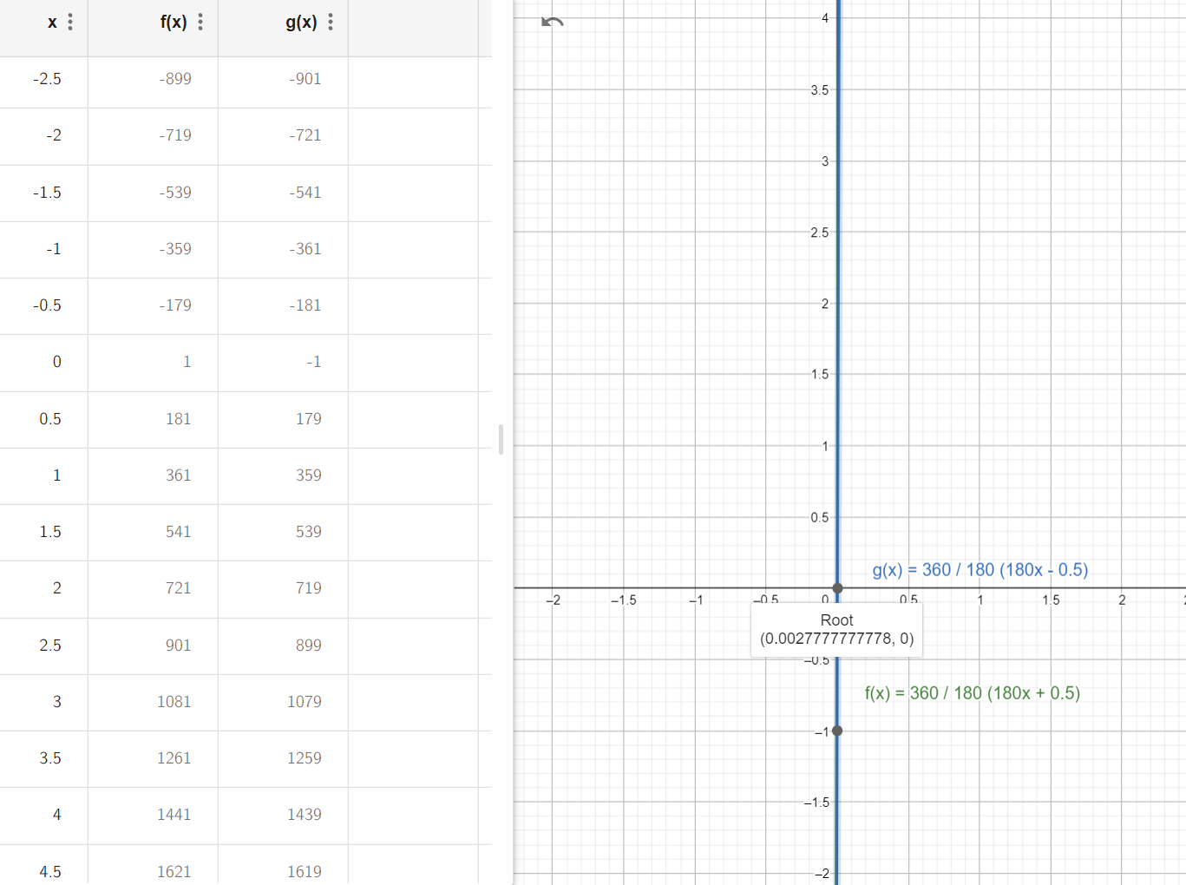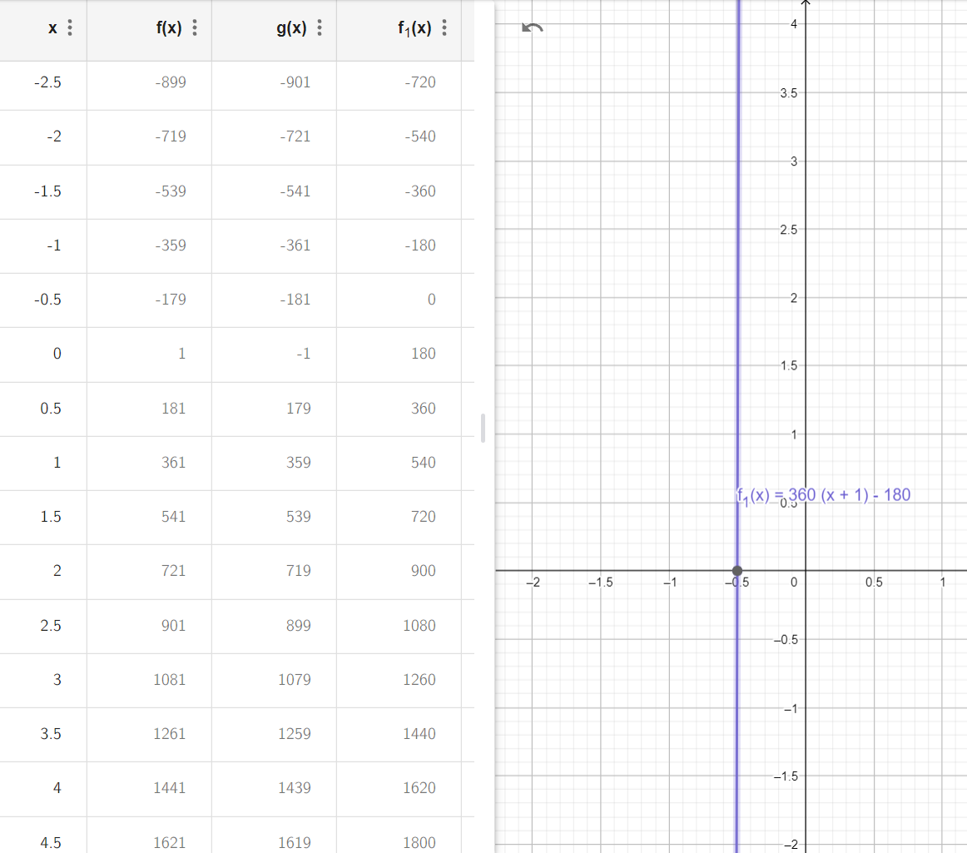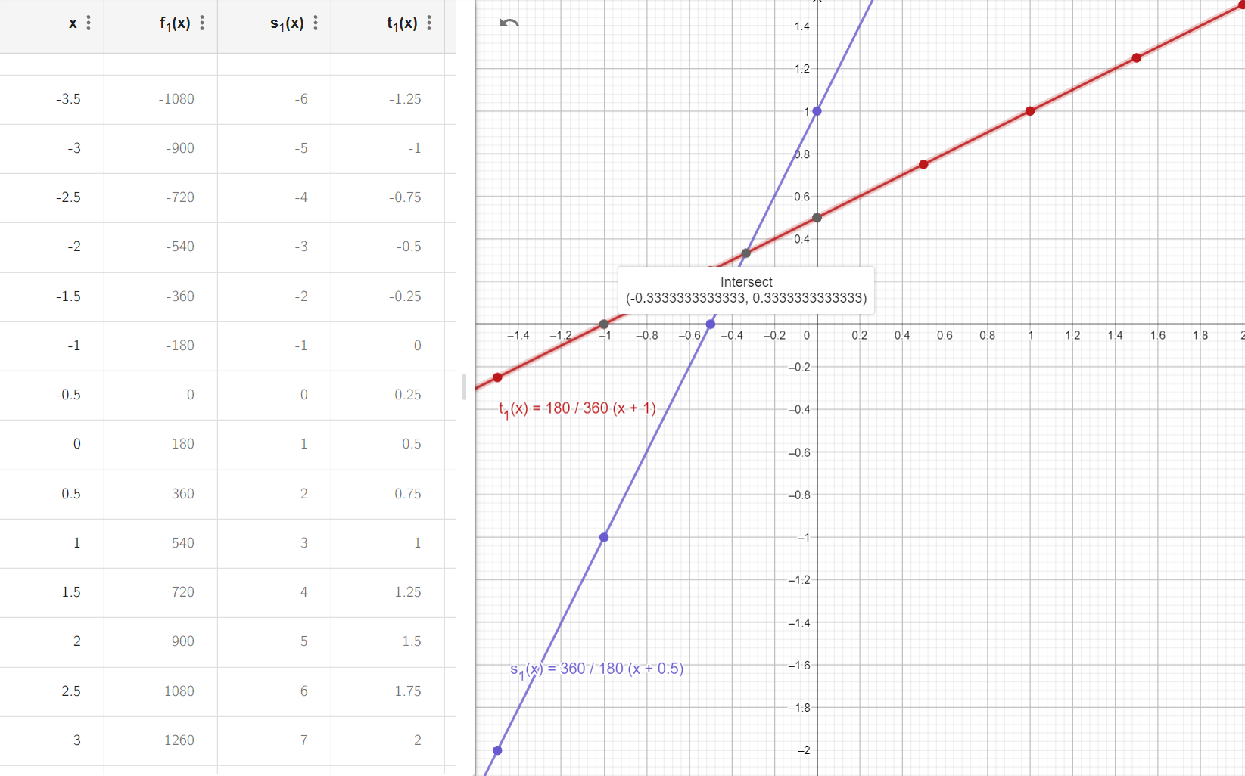

S(X) intersect with t(X) at point ( ,); Why?



1. Simplify S(X) and t(X)

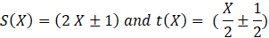

For t(X) liner relation with Y intercept = ½

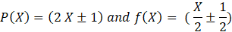

To keep the X intercept point at X = -1 for f(X) to be = 0

It must intercept Y at 1/N For

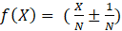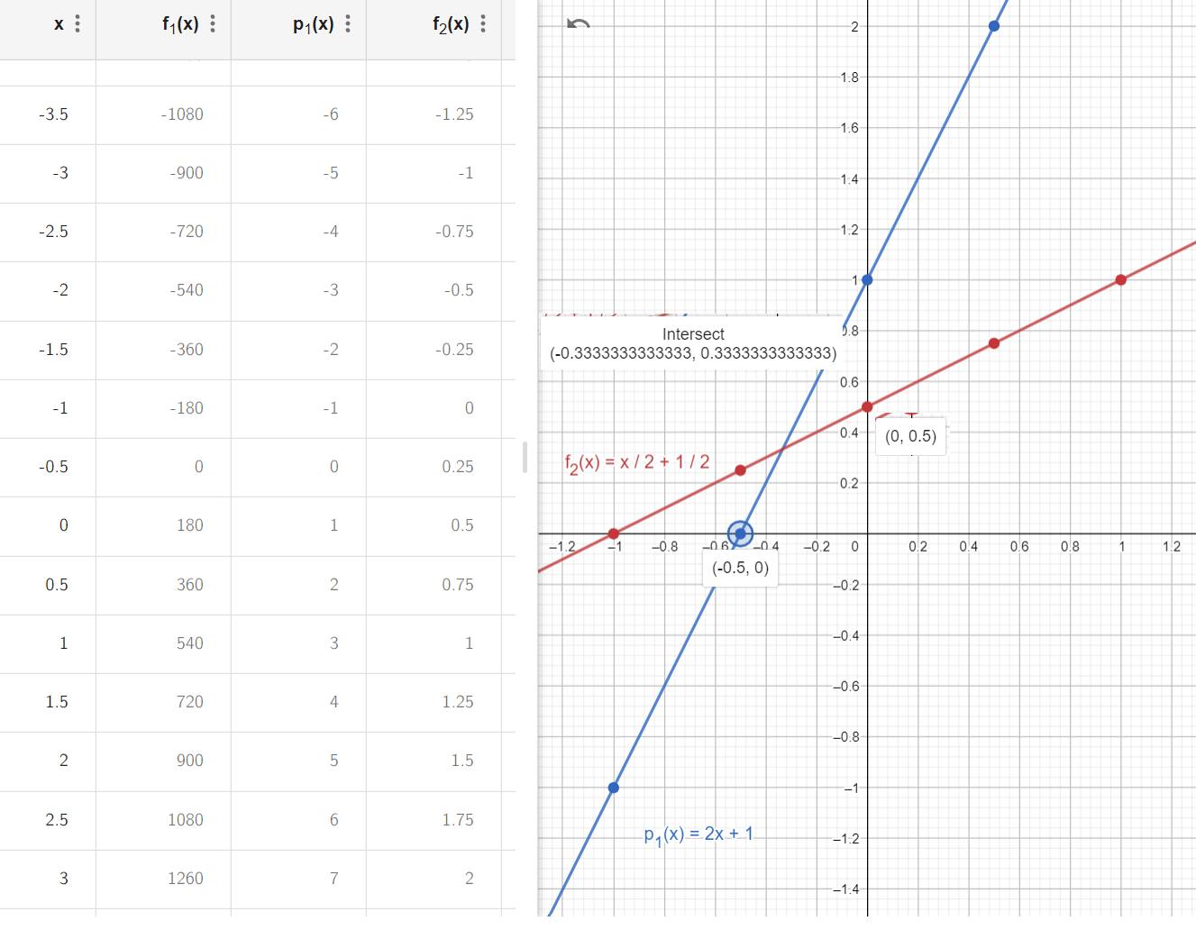

1. Each line intercept Y at



1. Each line intercept with line at point

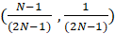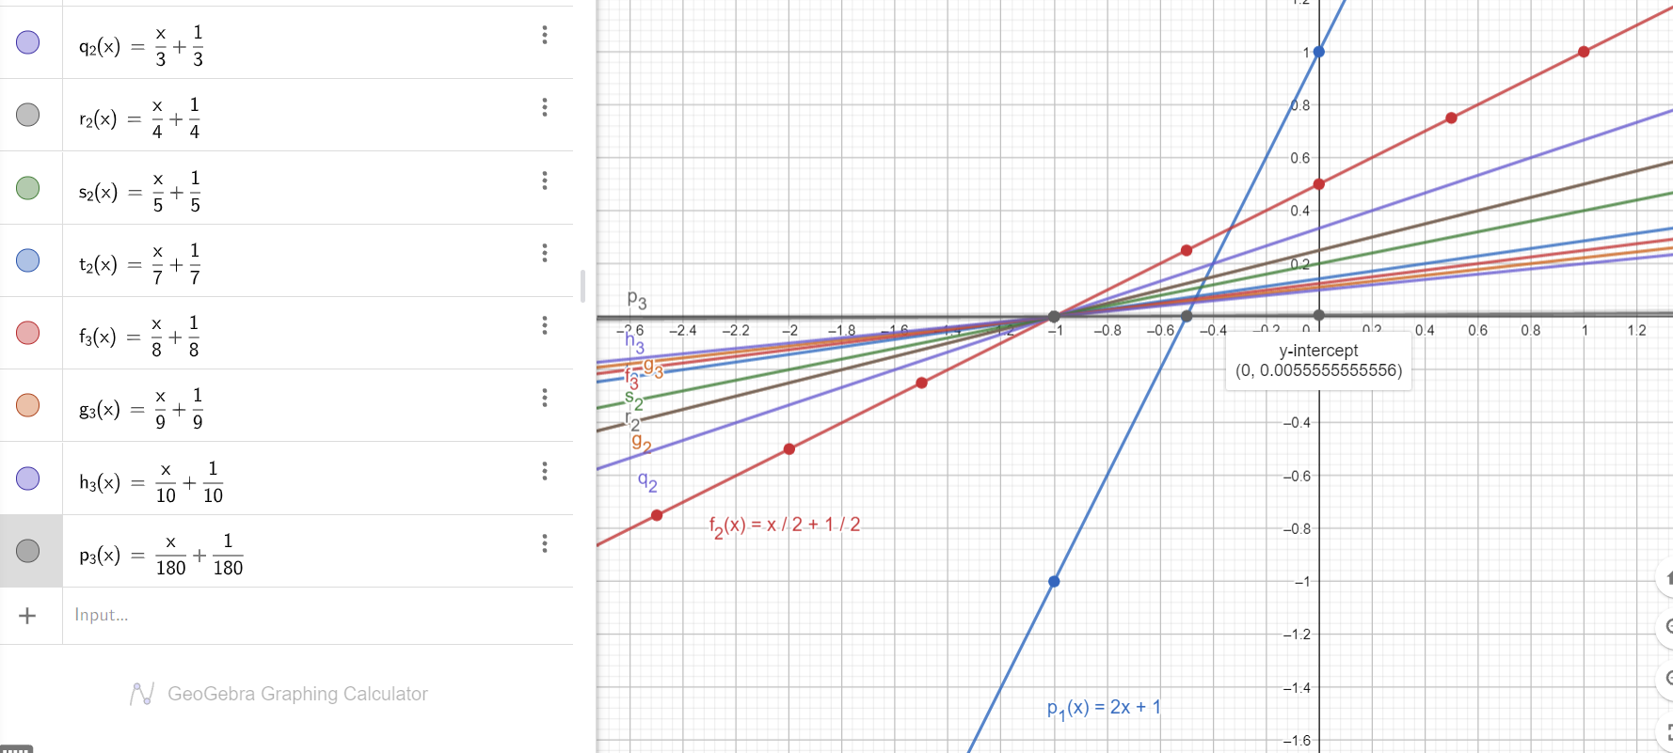

At N = 180

1. Each line intercept Y at

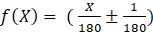

1. Each line intercept with line at point

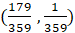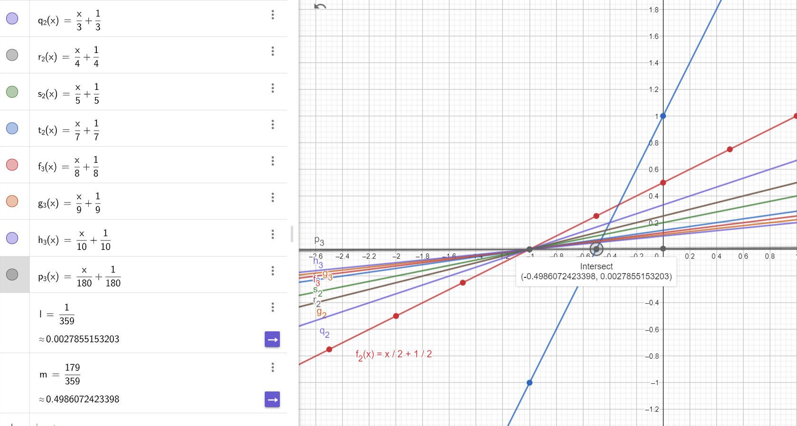

At X = 8

1. Each line intercept Y at

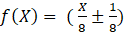

1. Each line intercept with line at point

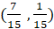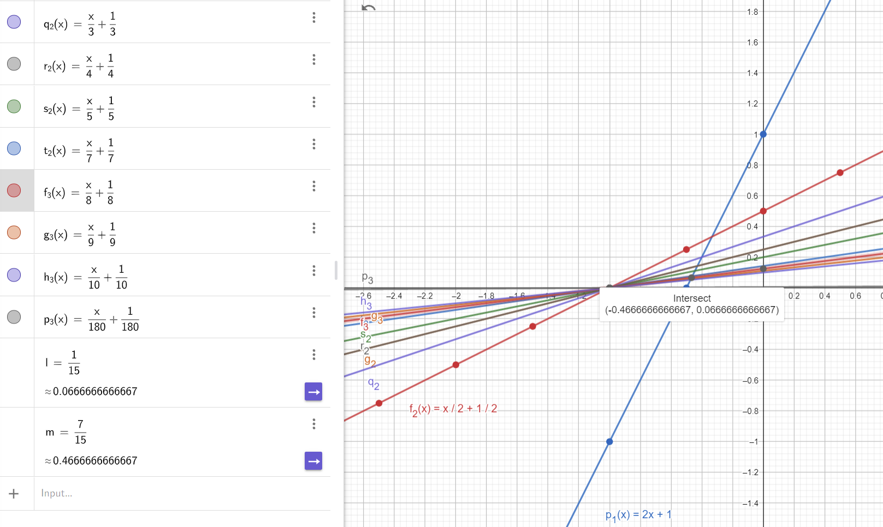

We can write this relation as

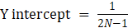

If X = N – 1.5

Then



*Which is a linear relation rotates 360 degrees around point ( -1 , 0) for any value for N*

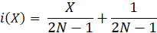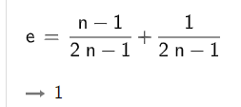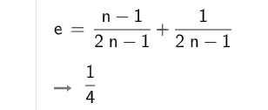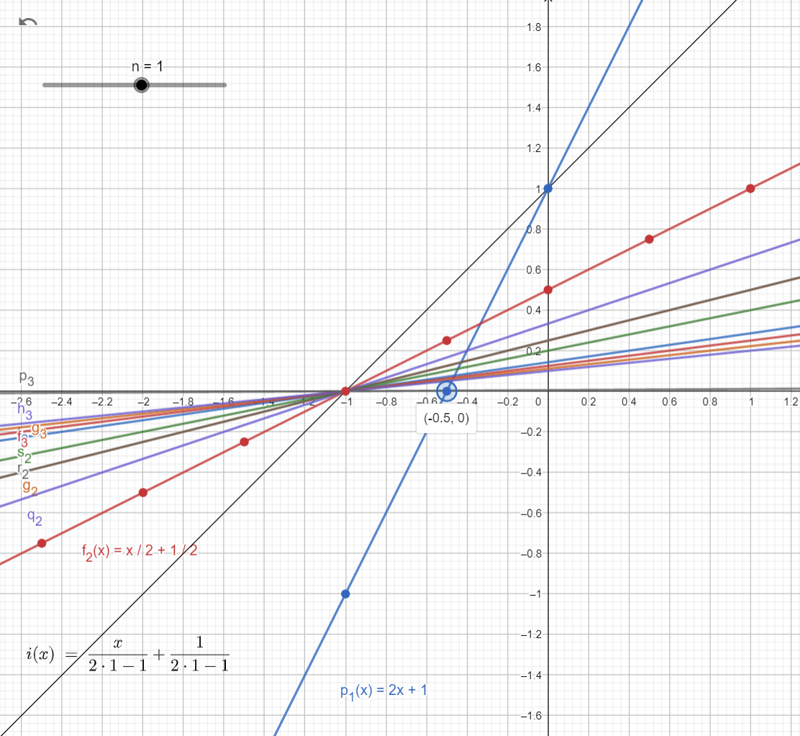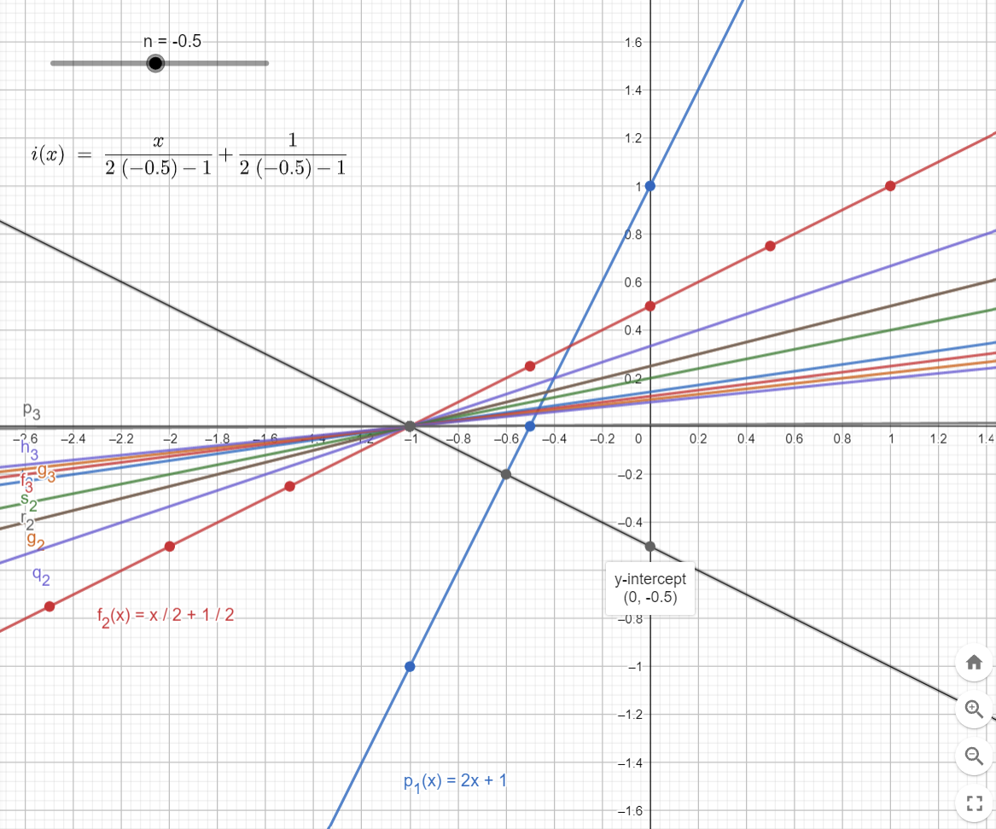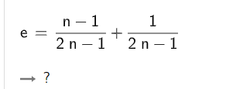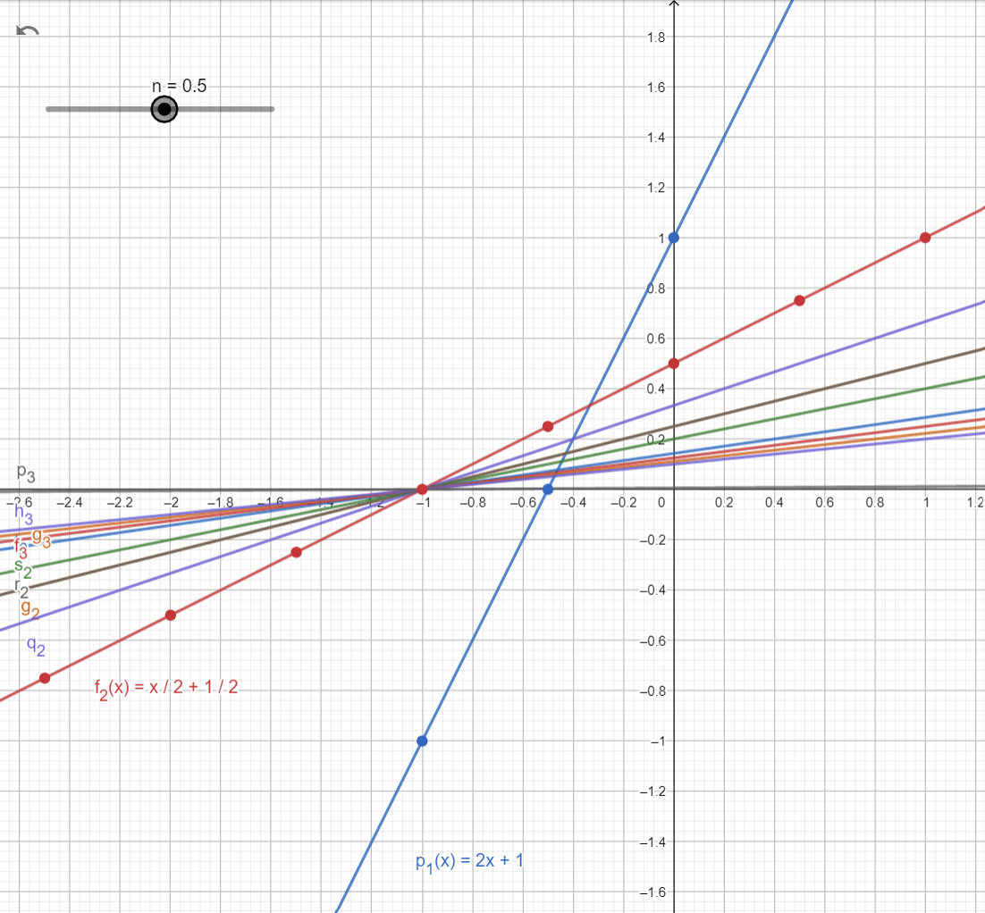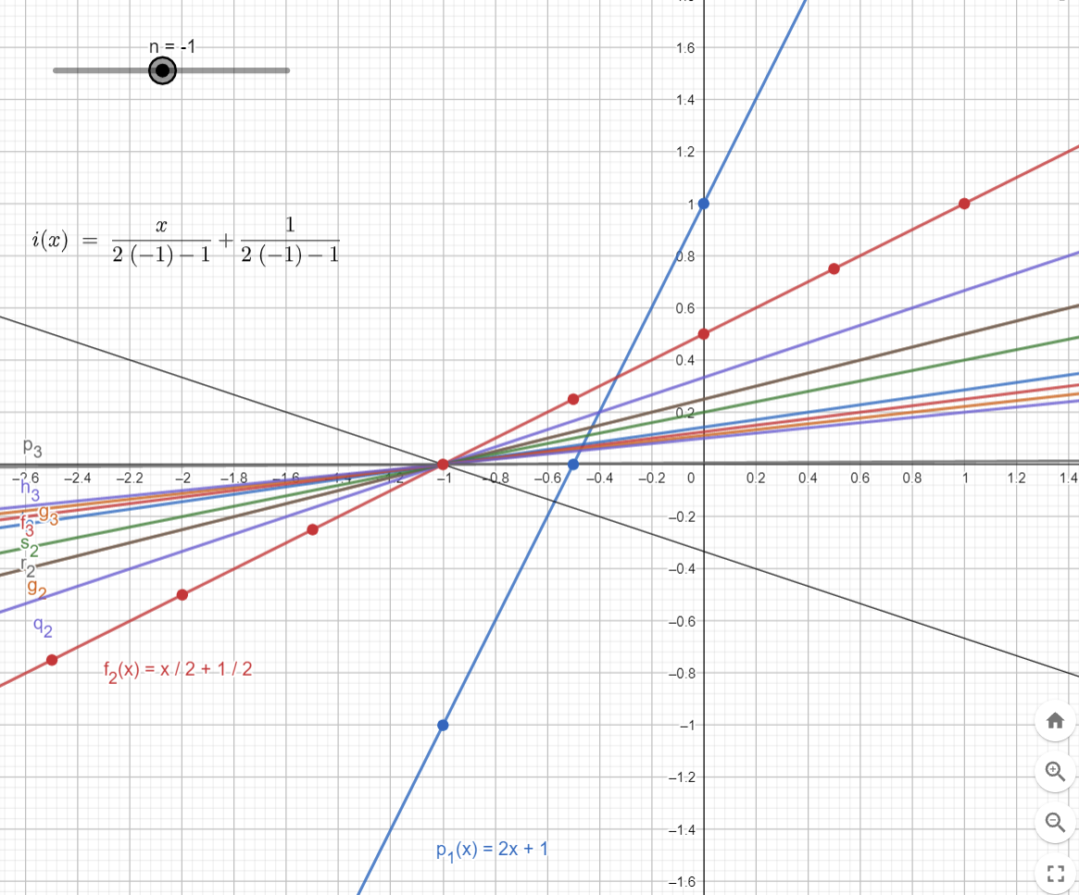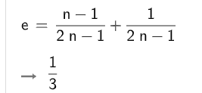

when N = 0.5 denominator is Zero so no value for i(X) or infinity for any value for X.

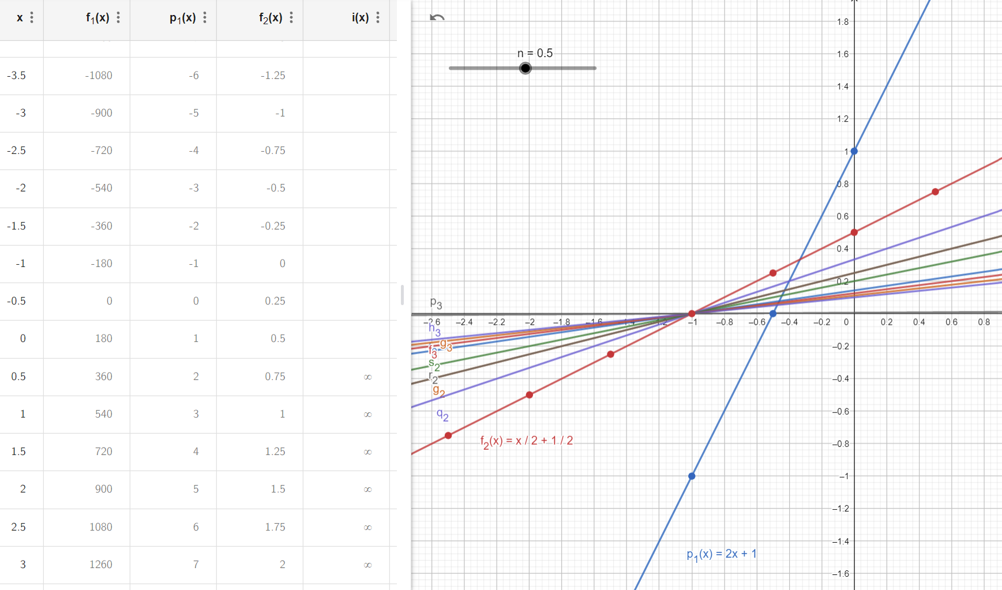

Let X = X-1 THEN

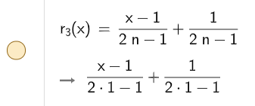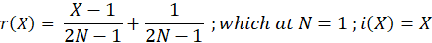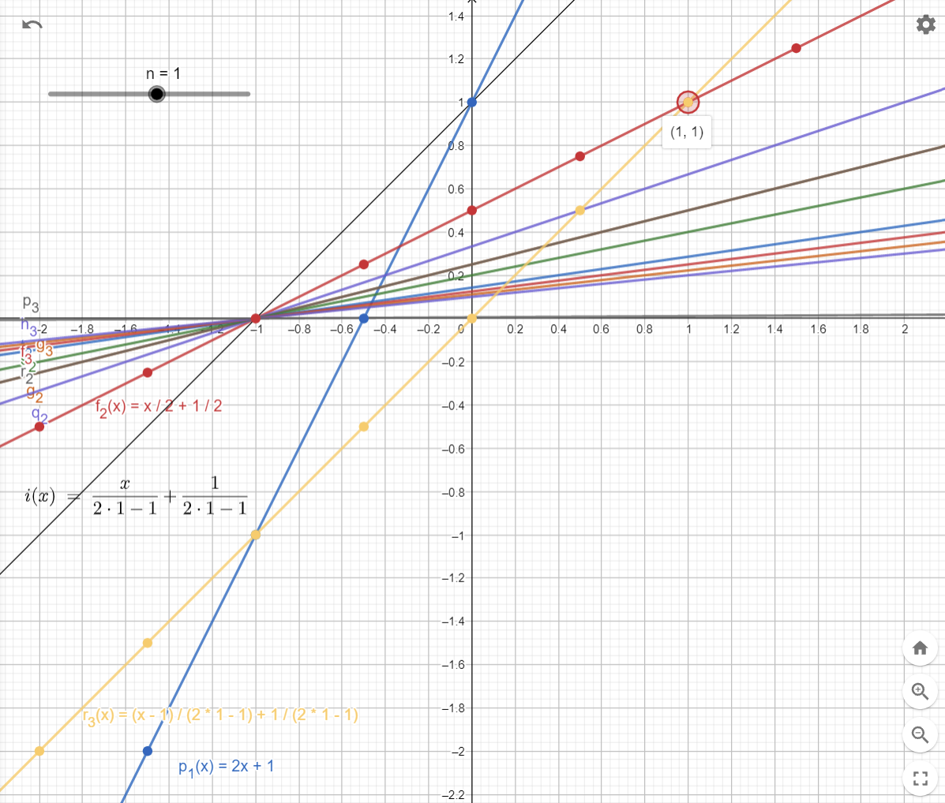

Intersect with each Line

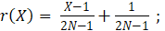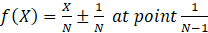

Intersect with each Line

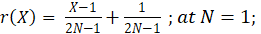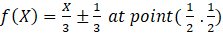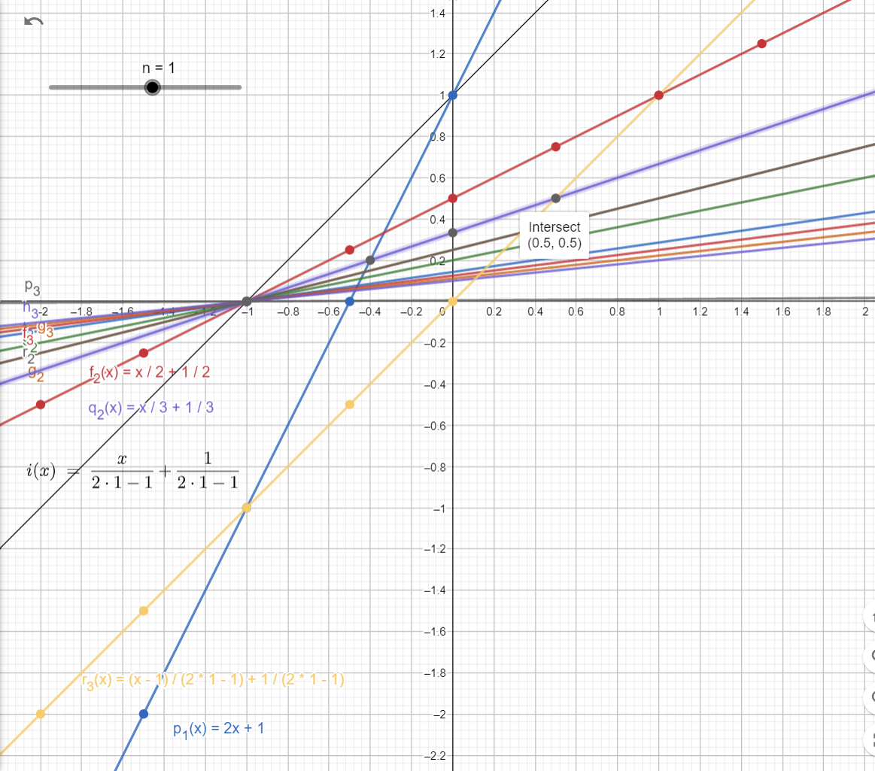

Intersect with each Line

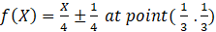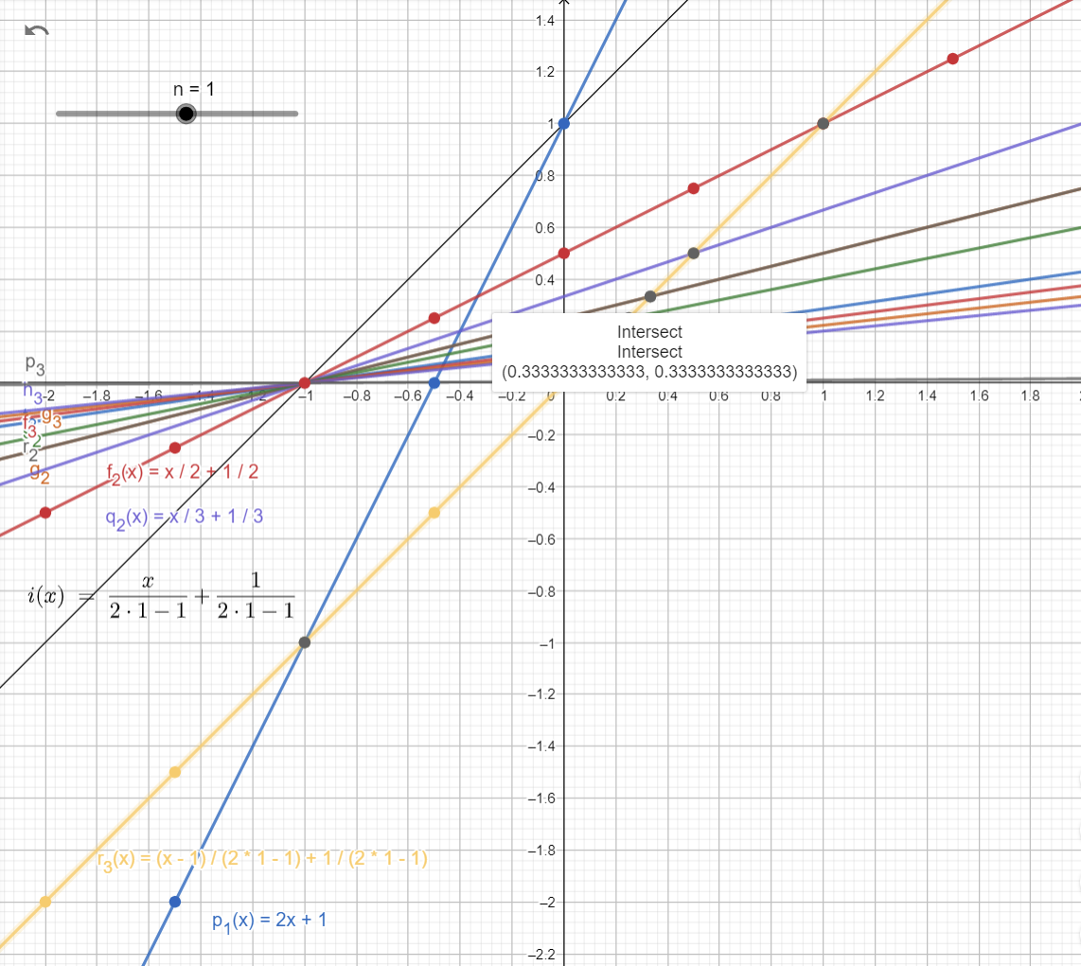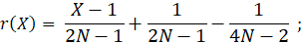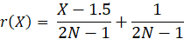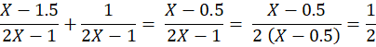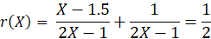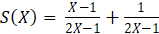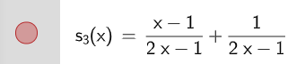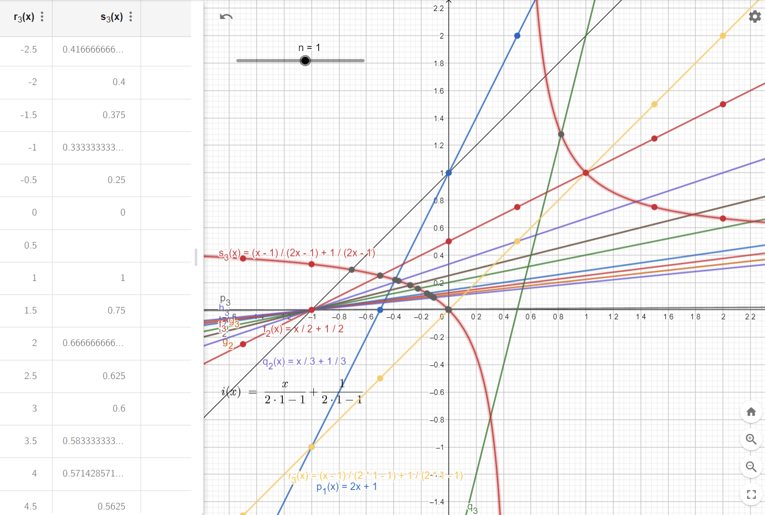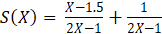

As we explained before this is a ratio = 0.5 regardless of the value of X. where X≠ 0.5

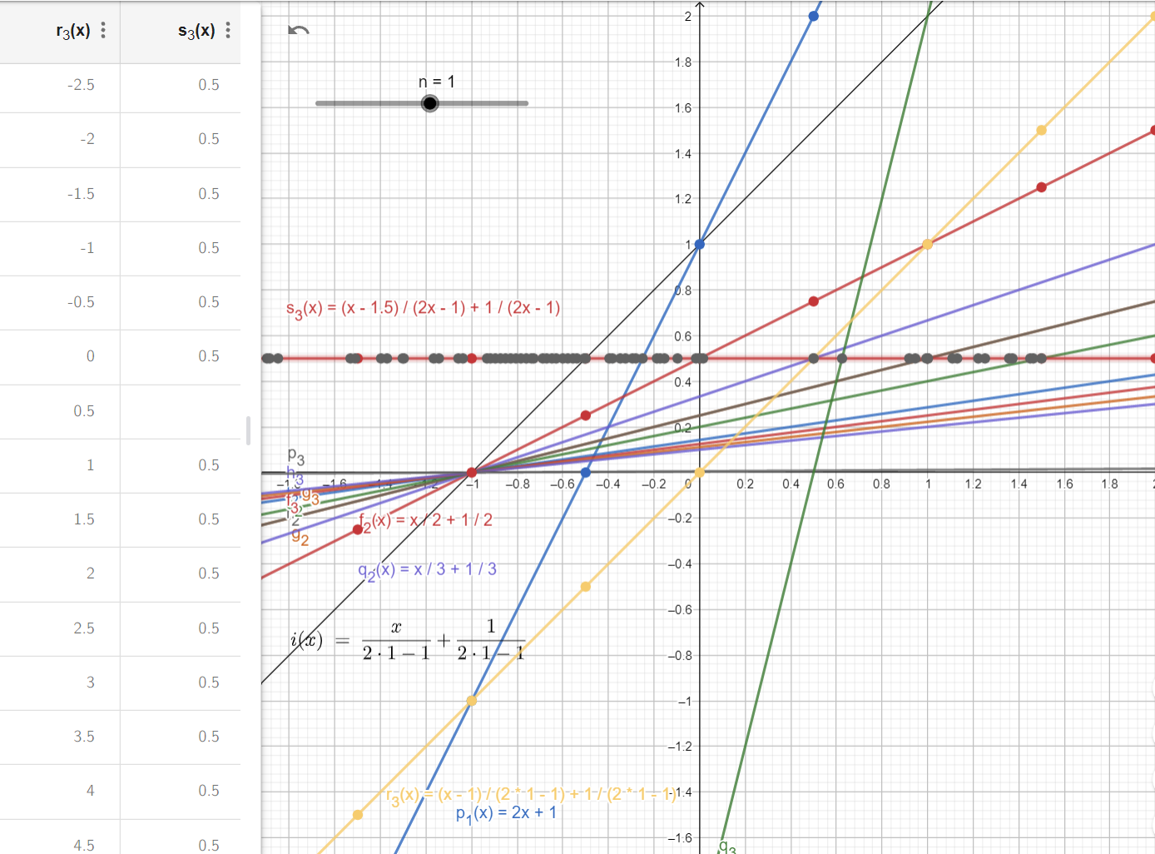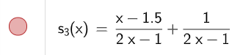





This 0.5 is due to subtract this term ; Change this term back to degrees, TEHN

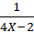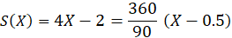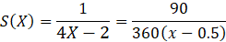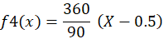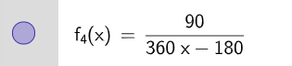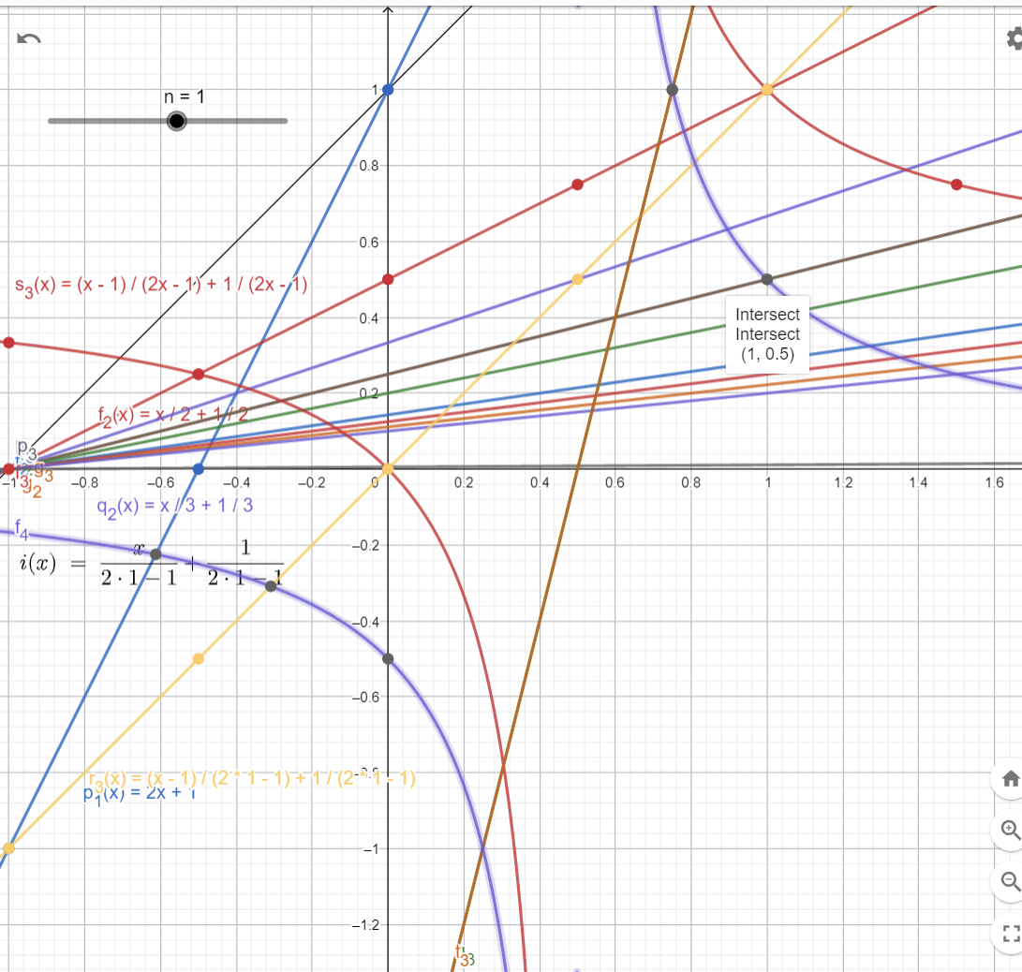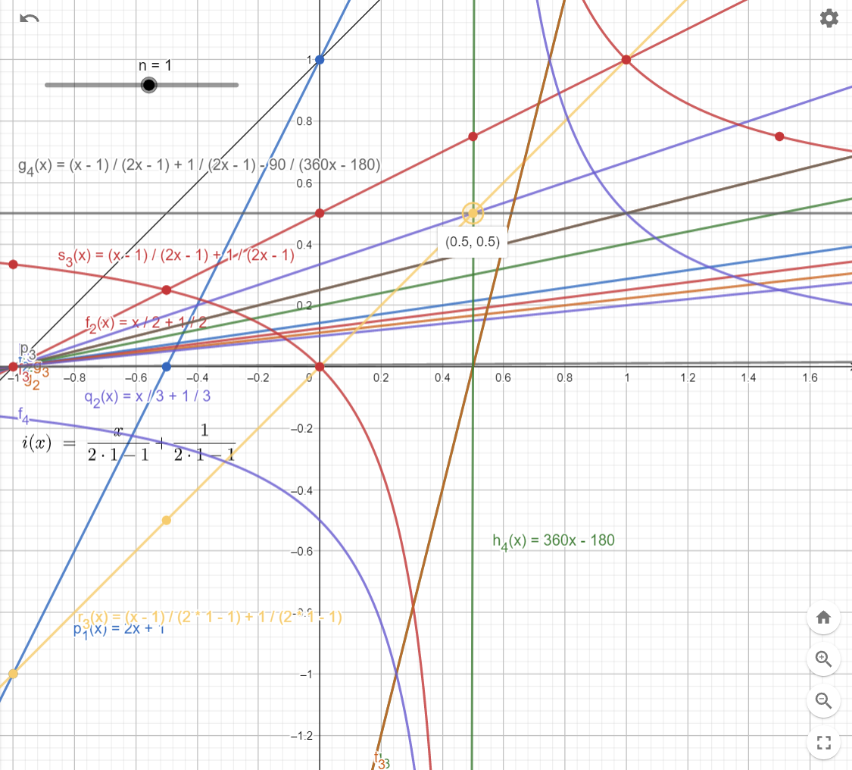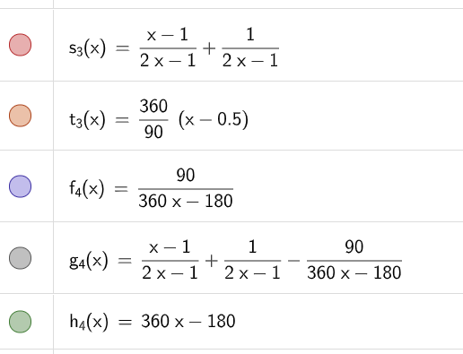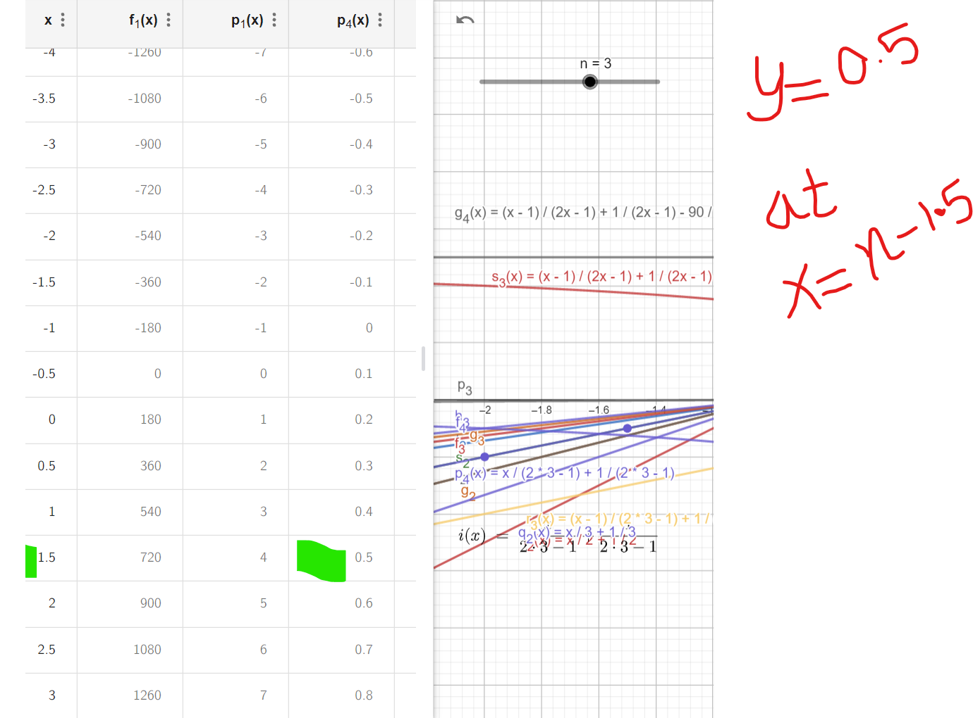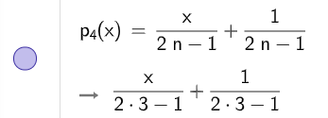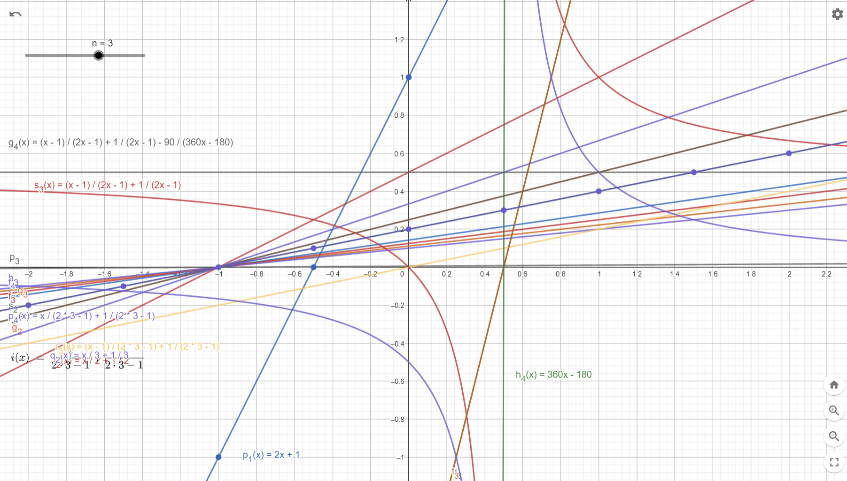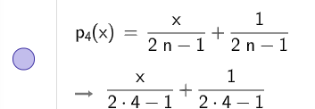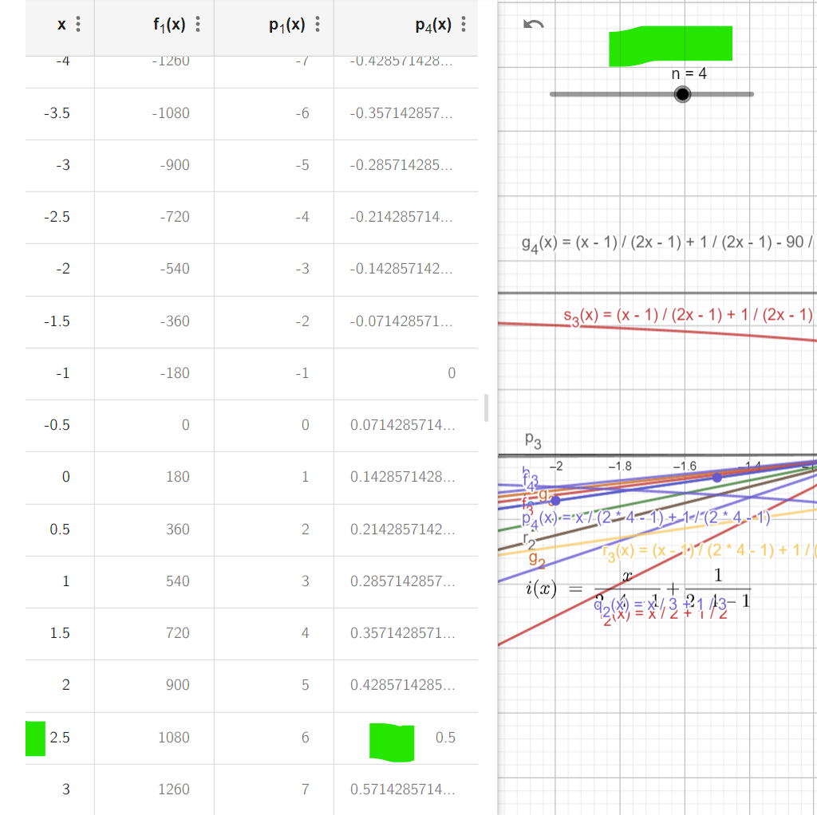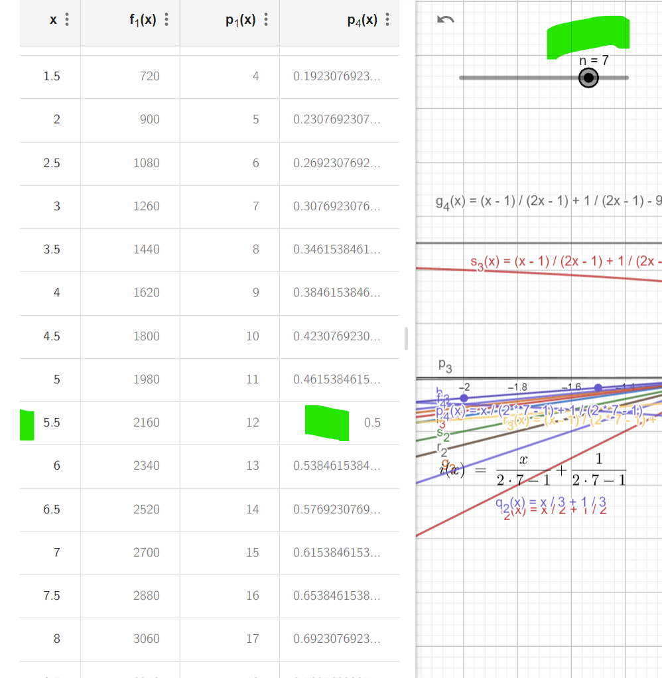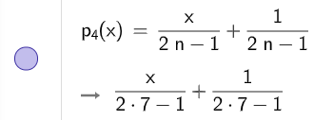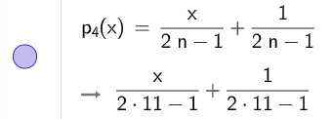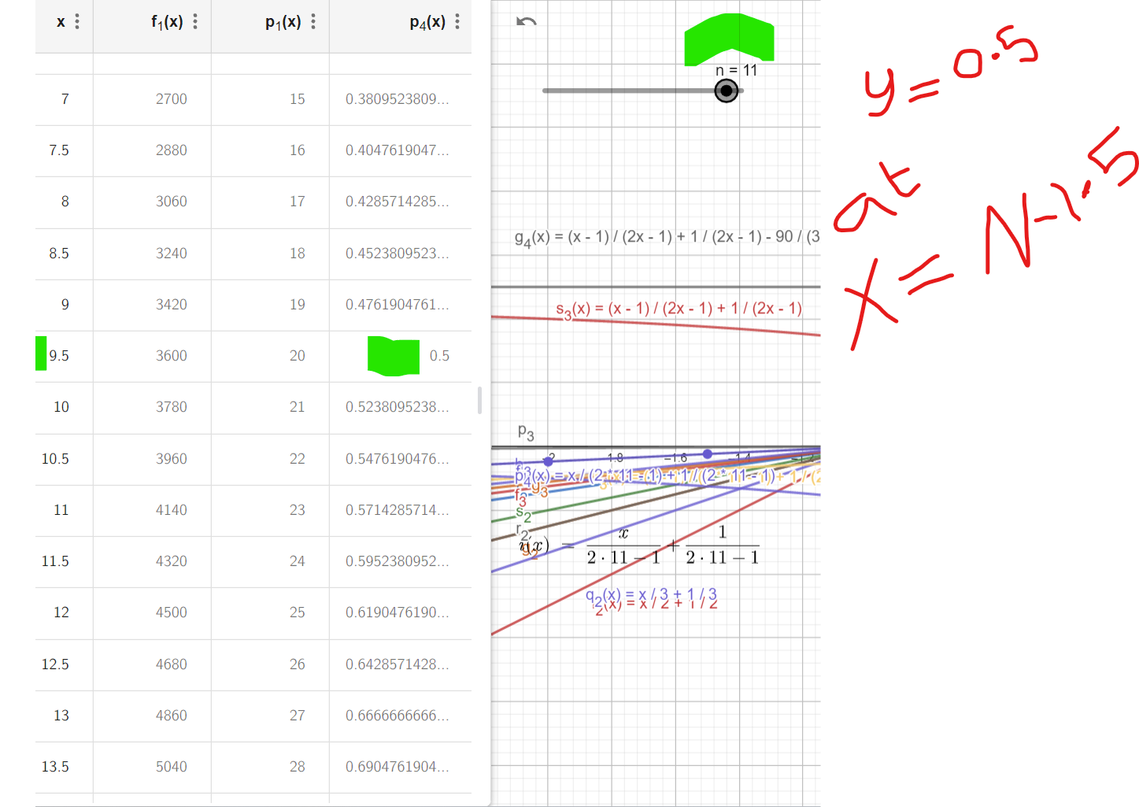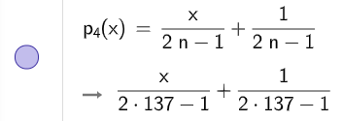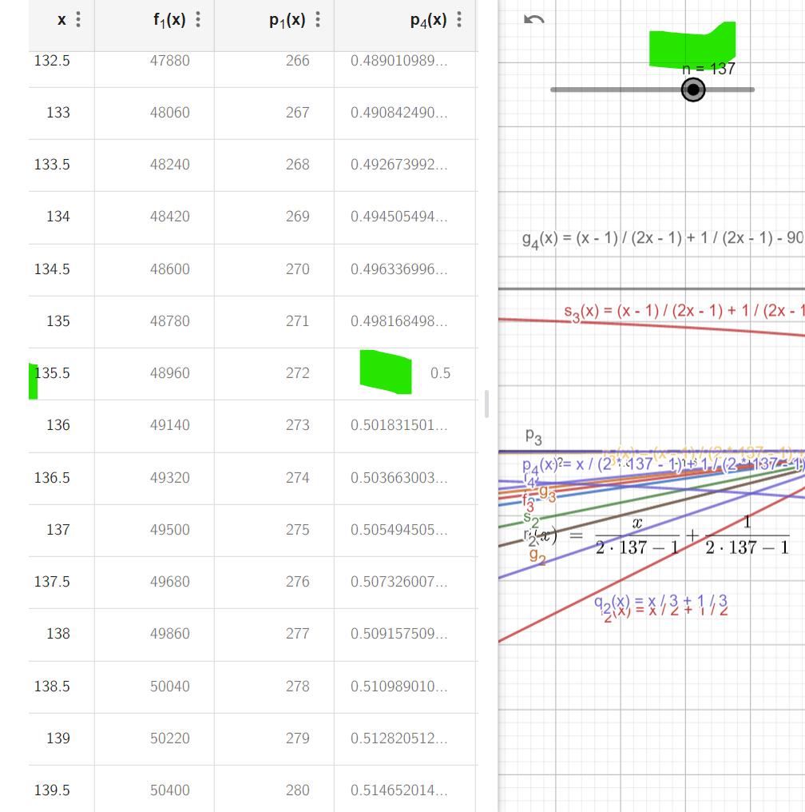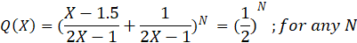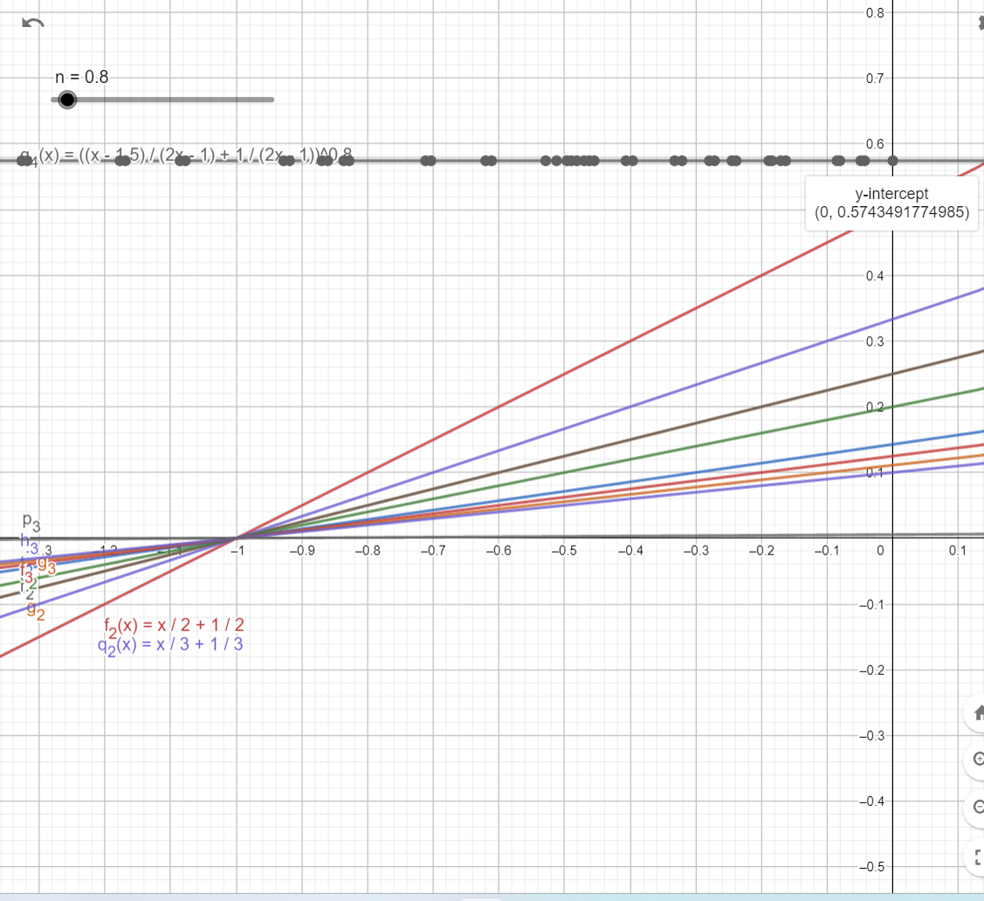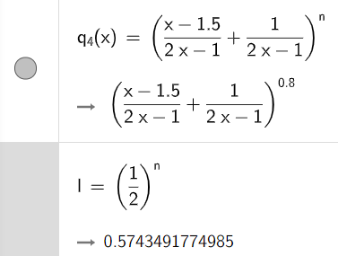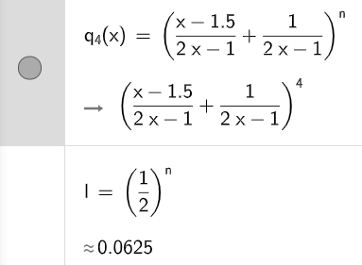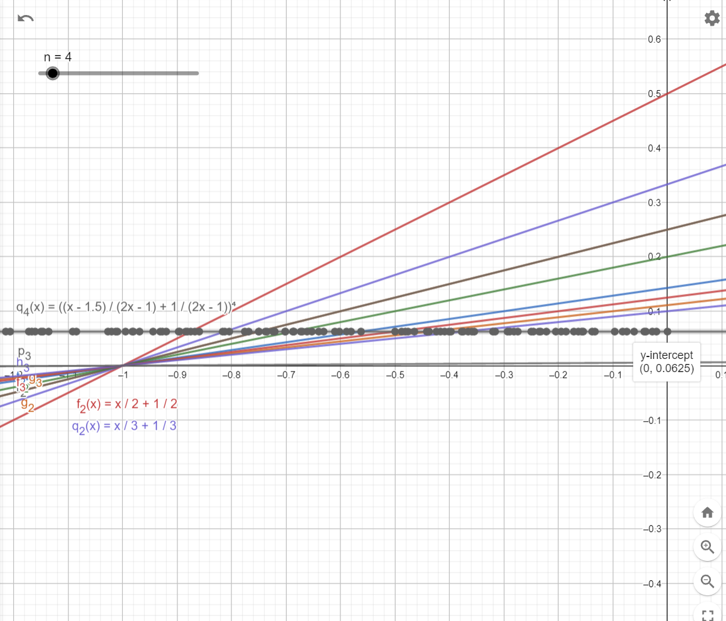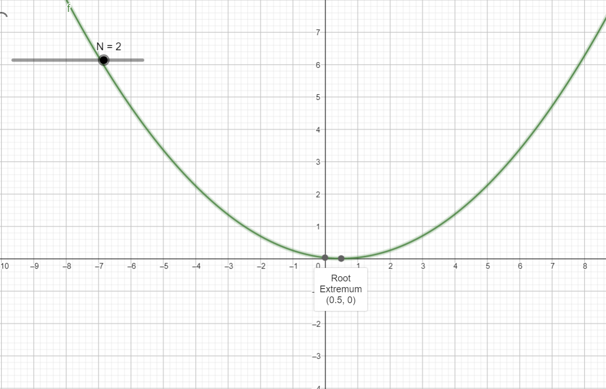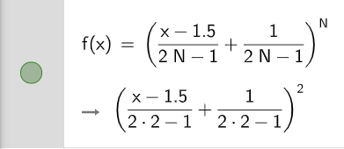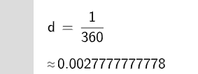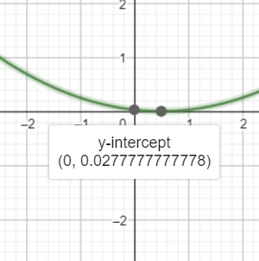

For X = 0.5; for any N ≠ 0.5; F(X) = 0; all the time; F(X) = 0 if 0.5 < X < 0.5

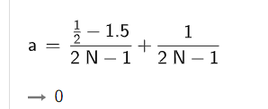

IF N = 0.4 and X = 0.5 THEN F(X) = 0

IF N = 0.6 and X = 0.5 THEN F(X) = 0

IF N = 0.5 THEN F(X) unknow

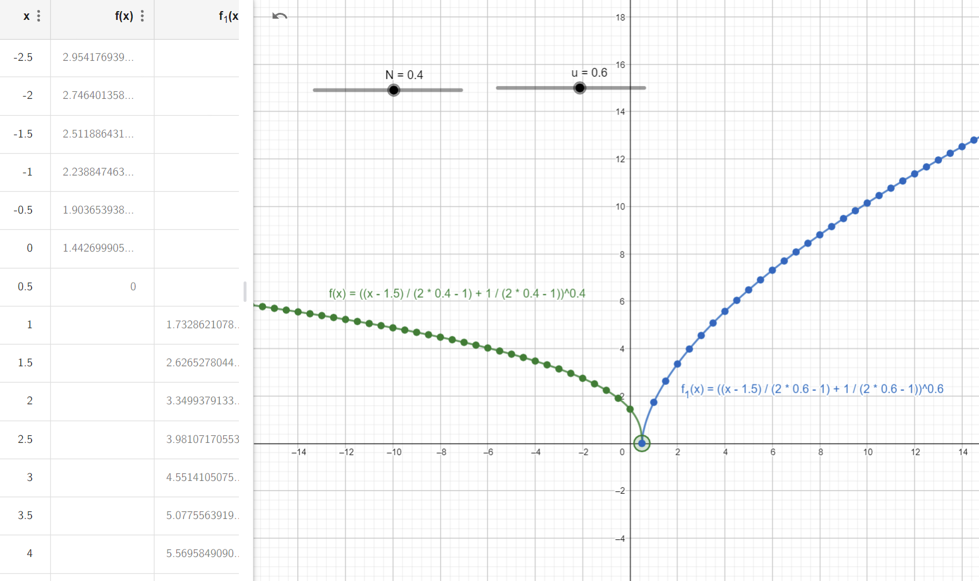

IF X = 1/1; N =1

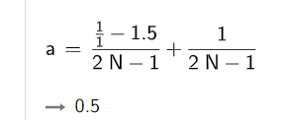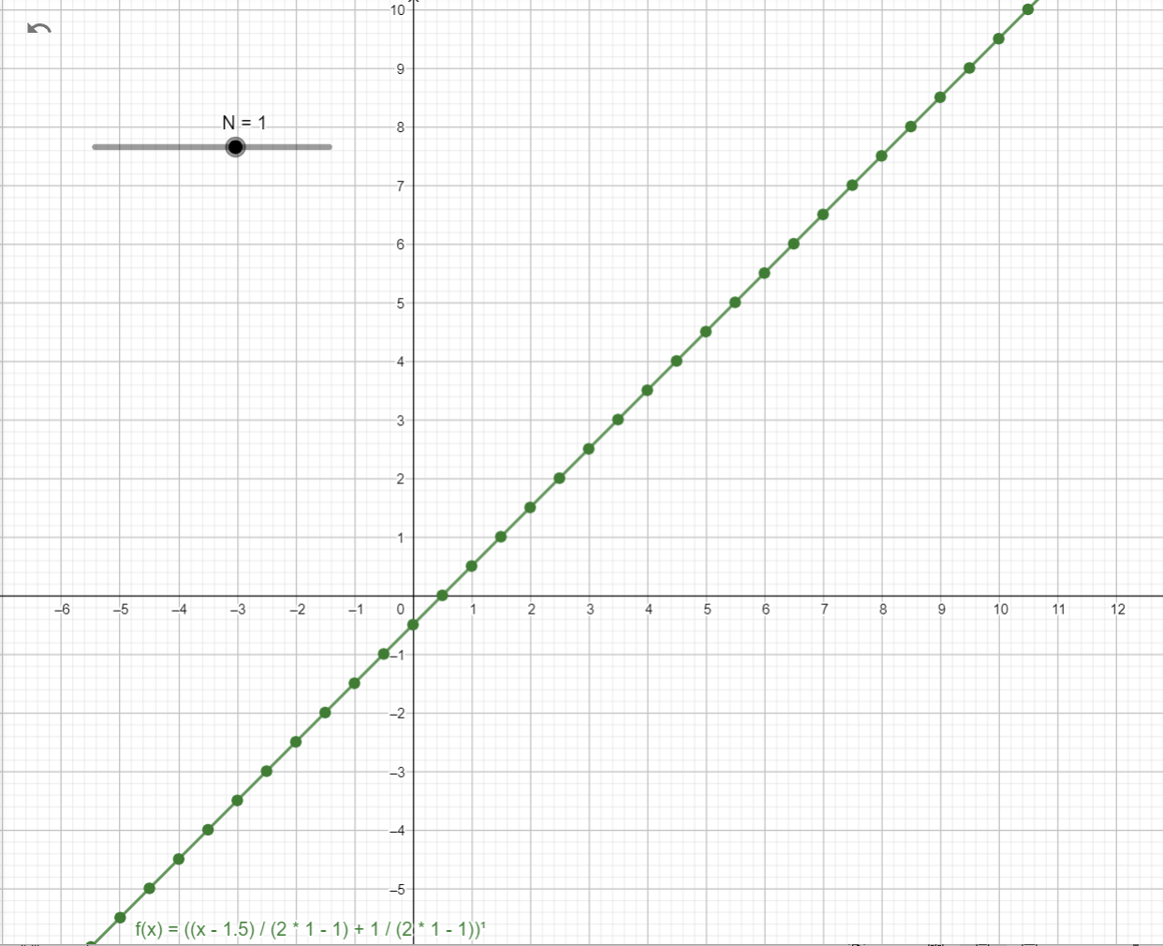

Symmetry Properties for N ODD numbers

Main property for N = Odd numbers they are symmetric over new axis intersection of two functions ;

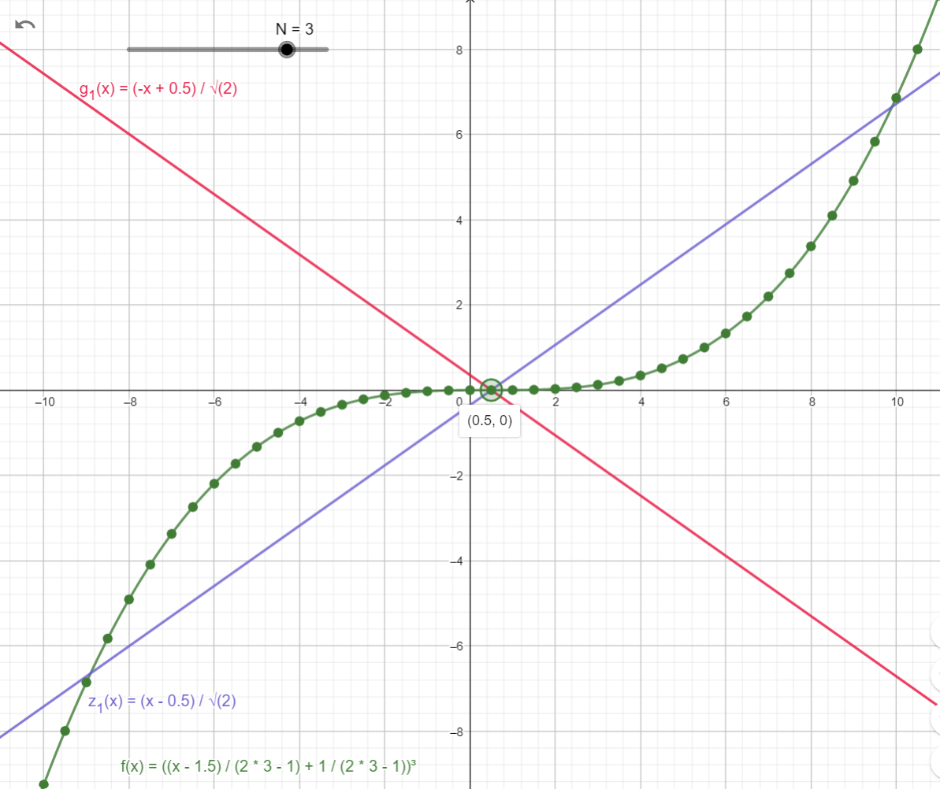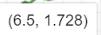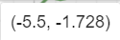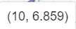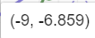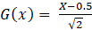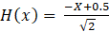

But, For N = Even numbers the graphs are symmetric over Y axis. Or more specific over X = 0.5

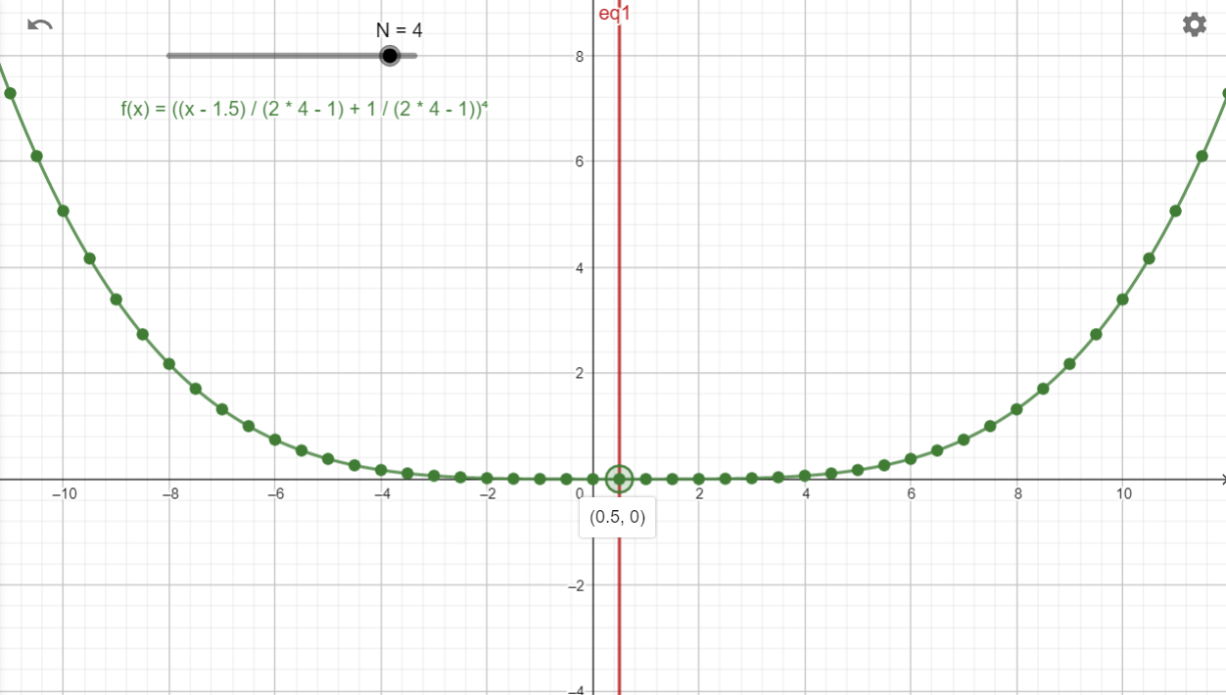

But, because denominator = (2N-1) THEN at N = X = 0.5

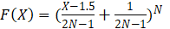

F(X) = is unknown at X = 0.5.

So, we are going to use the symmetry property over axis; we will use small interval X = [0 ,1]

And will get F(X) at one of the edges of this interval.

One of the values will be with opposite sign because F(X) Nominator (X-1.5 +1); if X = 0 THEN F (0) = (0-1.5 + 1 = -0.5) all the time = -0.5 and if raised to odd power will be negative for any N = ODD.

Same will be for the other Edge because F(X) Nominator (X-1.5 +1); if X = 1 THEN F (1) = (1-1.5 + 1 = 0.5) all the time = 0.5 and if raised to odd power will be Positive for any N = ODD.

And as the values between these two sides of interval X = [0 ,1] one F (0) = Negative and F (1) = Positive then for sure one Zero will be between this interval [0,1] and because it is symmetric over axis ; so for any N = X = ODD a Zero will be at point (0.5 ,0).

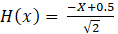

IFF X=1; ; for any N, will be a value F(X) at N=0.5 that we was not able to get if we substitute by N=0.5, instead of use the symmetry property for interval [0,1]



because value at X =0.5 in exact mid point between [0 ,1]; so, we get value for point (0, initial Y) from F(1) or F(0), by getting value at one of the interval edges so we will get the interval edge X=1 and both points at X = 1 and X=0 both will have same value initial Y. [ point1 = (0, -Initial Y) and Point2 = (1, Initial Y)]

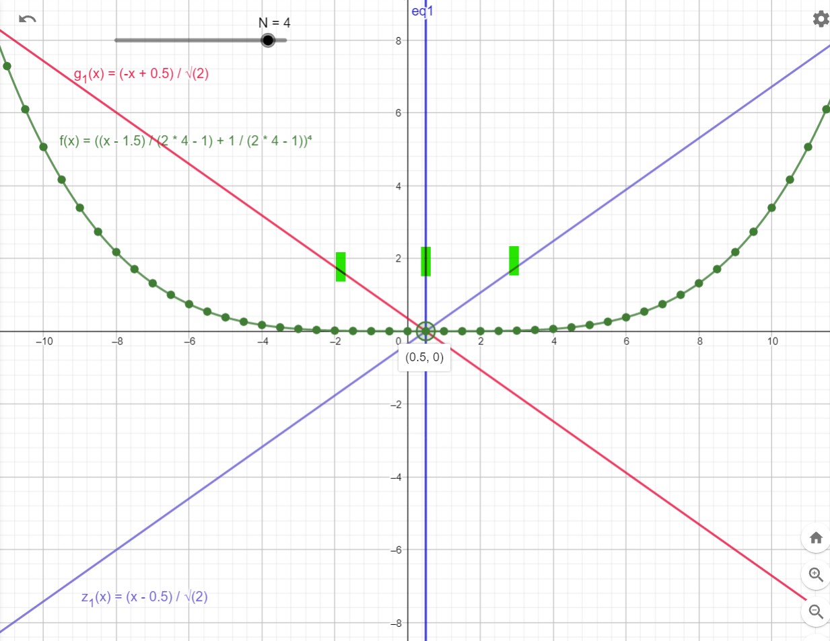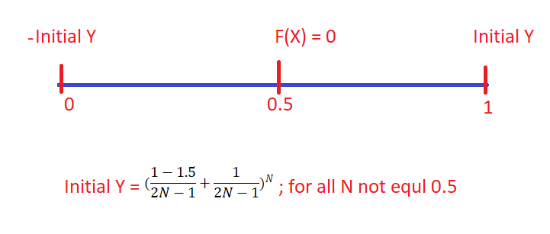

FOR X = 0 and N = 3 THEN



FOR X = 1 and N = 3 THEN



FOR X = and N = 3 THEN F(X) = 0



FOR X = 3 and N = 3 THEN

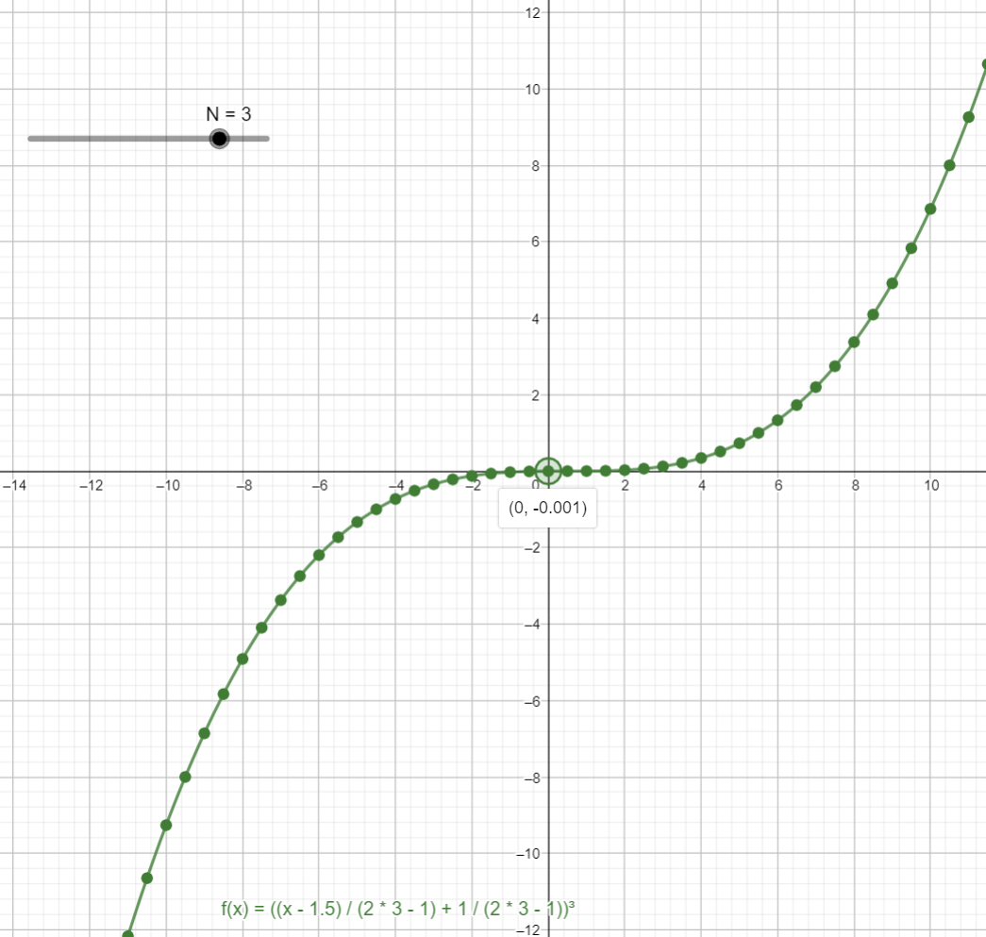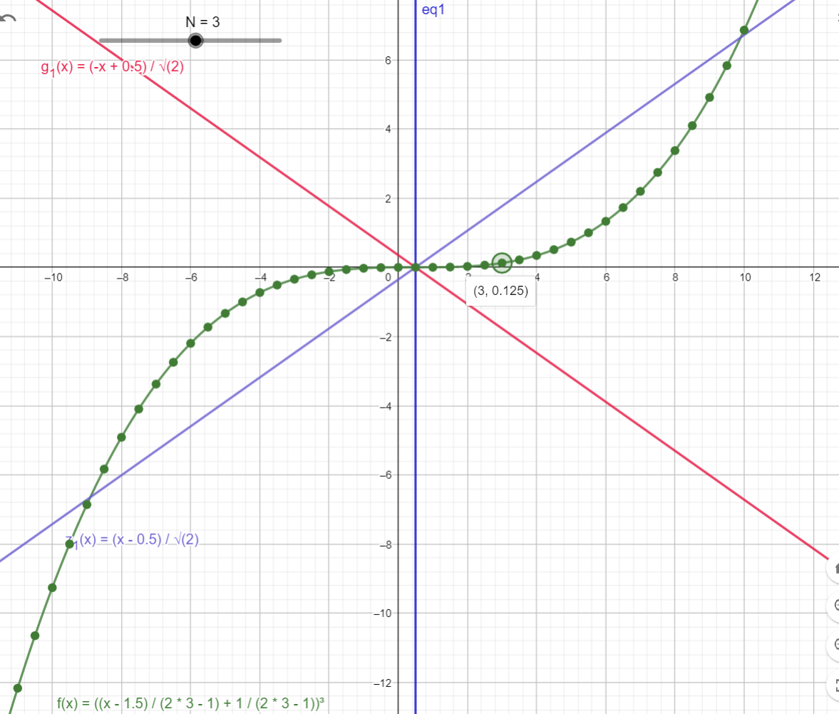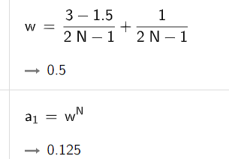

IFF N = N + 0.5



We only get half the graph because we basically move by step X = X -1. So, we only have half the graph but the same properties. And no symmetry on interval [0,1]. So now we have only half interval [0.5 ,1]

At X = 0.5 and N in {1, 2, 3, 4, 5…} THEN for all N because F(X) Nominator = 0.

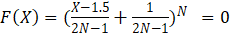

At X =1 and N in {1 ,2 ,3 4, 5….} and N = N + 0.5 THEN

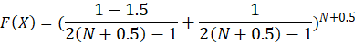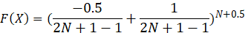

To get F (1): at X = 1

we can use N = {1.5, 2.5, 3.5 ,4.5 ,5.5, 6.5 ….} and

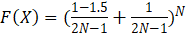

Or use N = {1,2,3,4,5, 6….} and

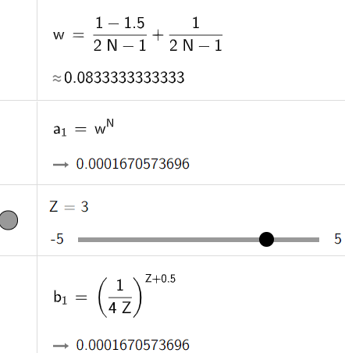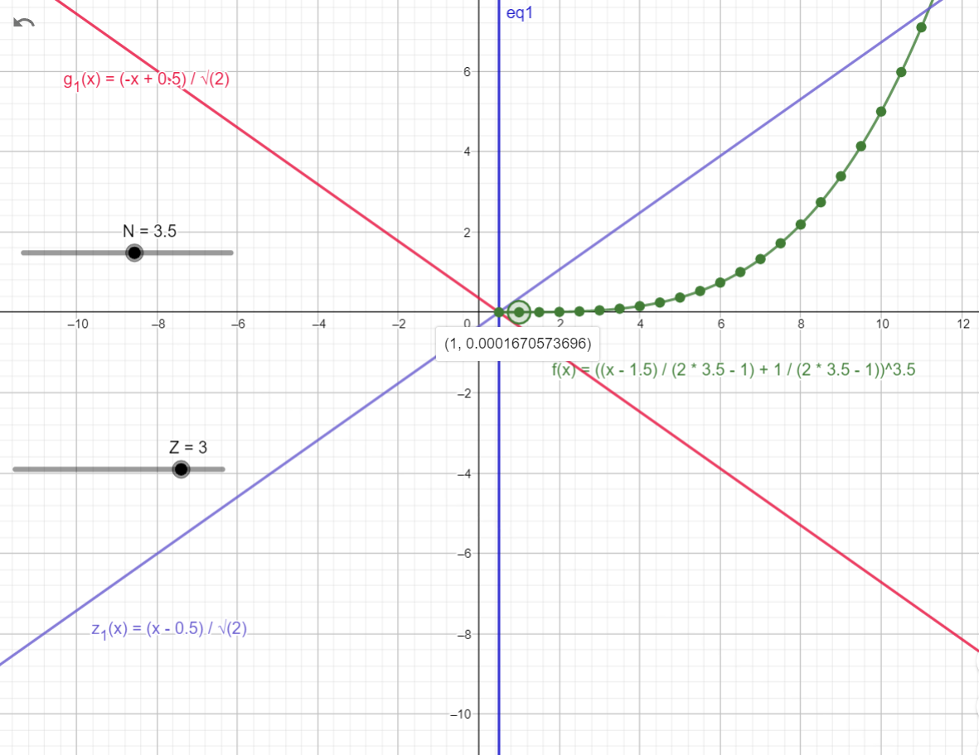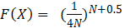

IF X =1/1; N = 1.5

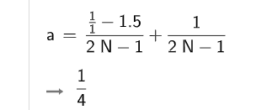

IF X =1/2; N = 1.5

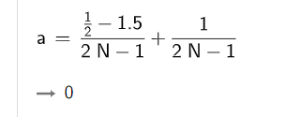

IF X = 1/3; N = 1.5

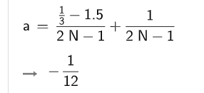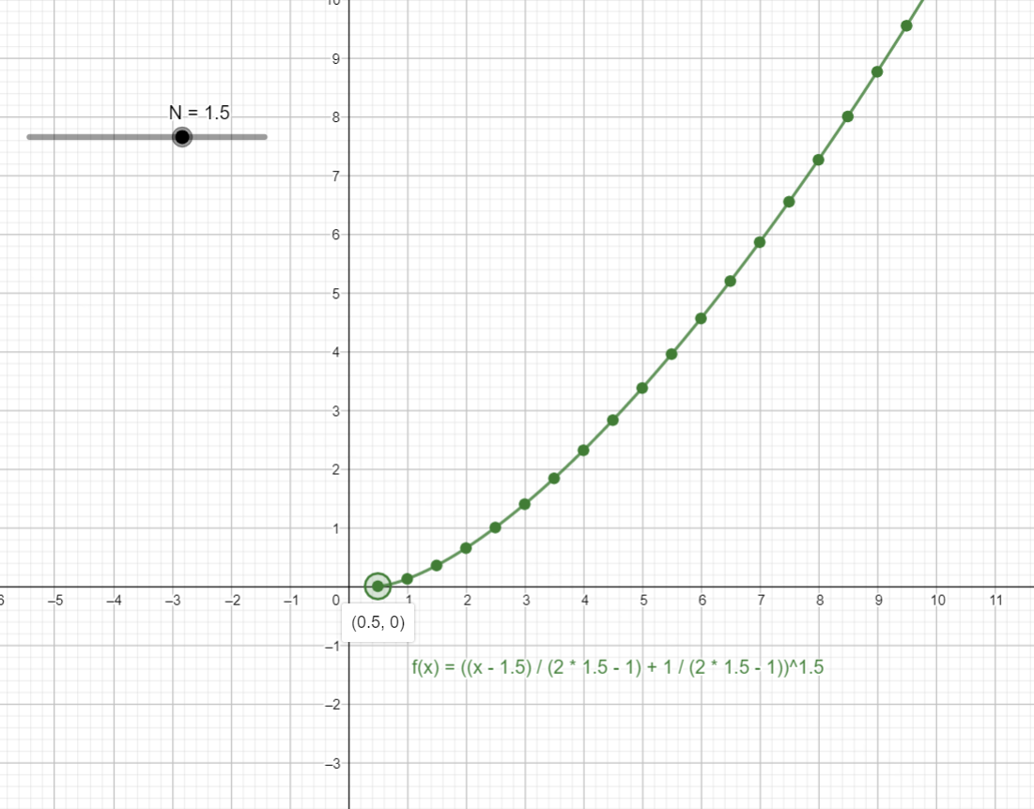

At X = 0.5 THEN F(X) Nominator = 0 for any N.

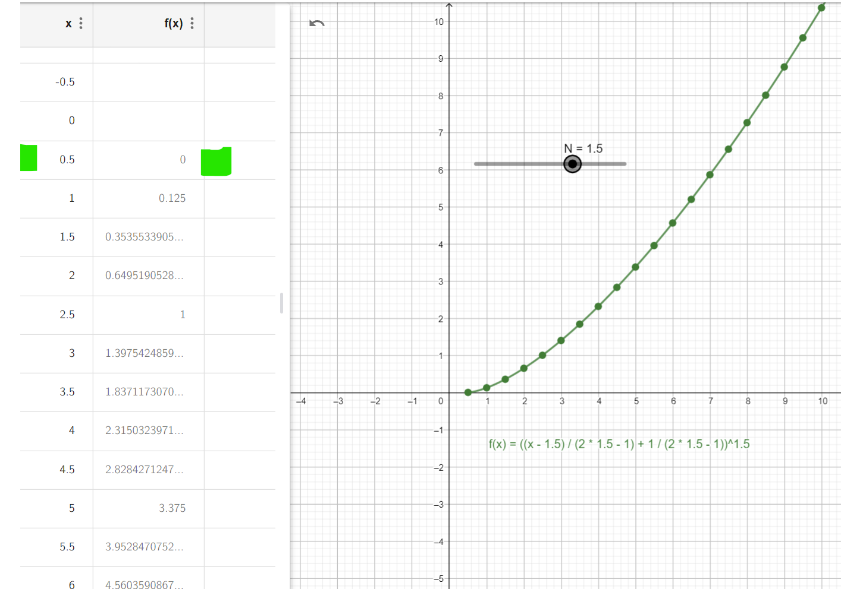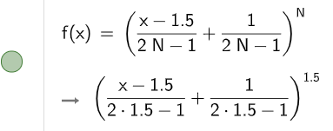

At N = 0.5 F(X) undefined because denominator = 0

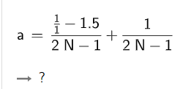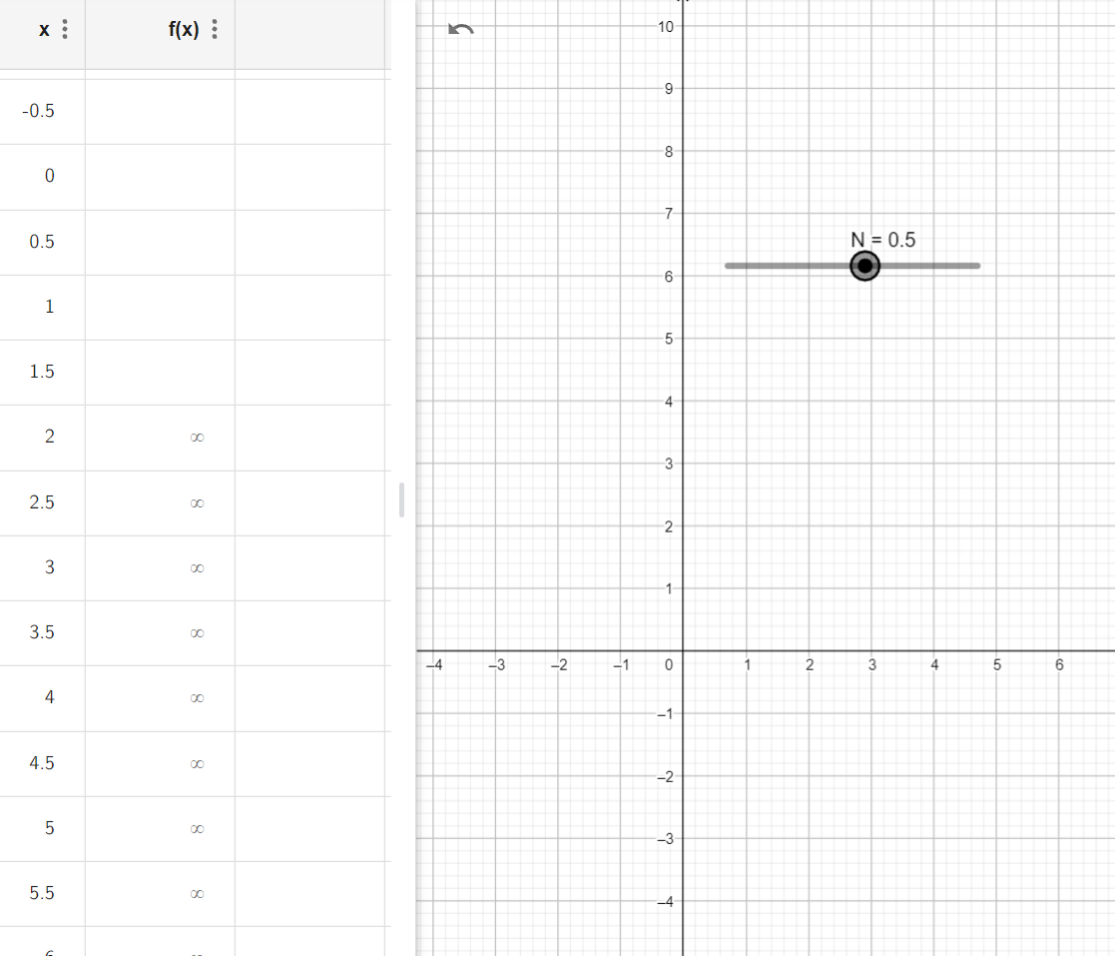

But at X =0.5 and 0.5 < N < 0.5 Then F(x) = 0 because nominator = 0.

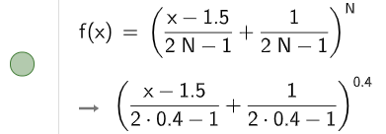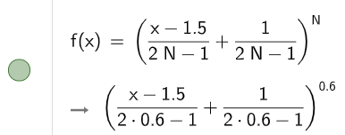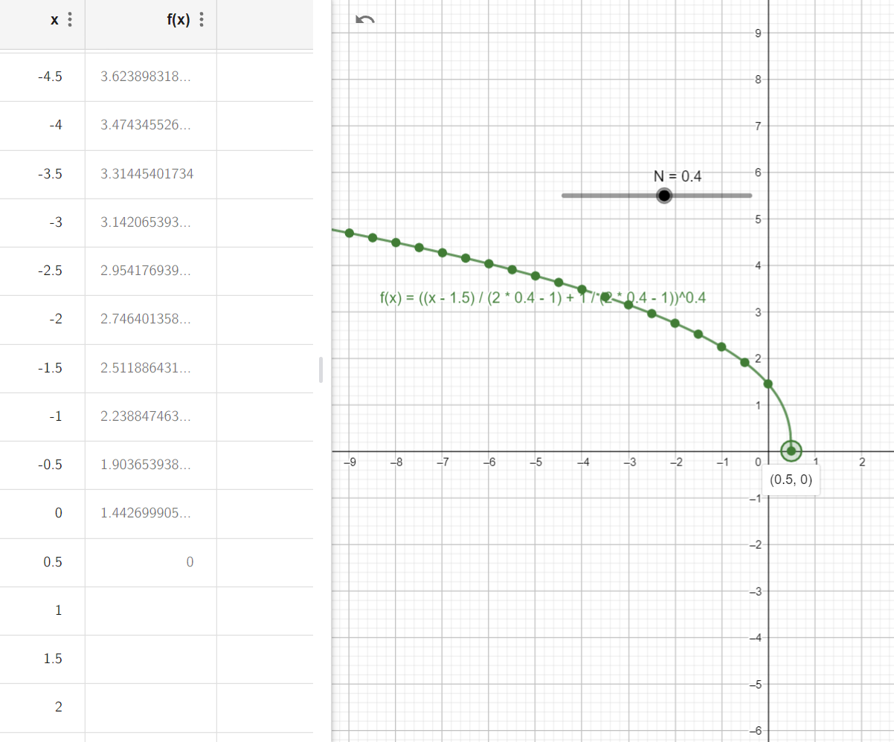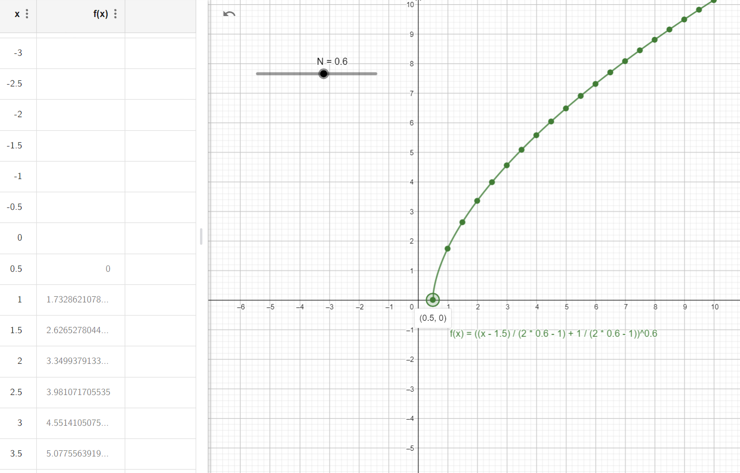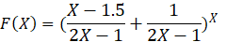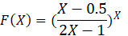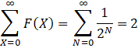

B)

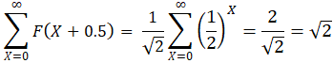

From A & B

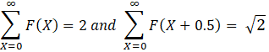

**Conclusion**

To get the reasoning of why we have none-trivial Zeros, and how number are distributed and how to get the exact value location for a Zero.

First, we got through the steps to introduce the new formula the new used this formula and its usage.

**References**

[*"Series expansion - Encyclopedia of Mathematics"*](https://encyclopediaofmath.org/wiki/Series_expansion)*. encyclopediaofmath.org. 7 February 2011. Retrieved 12 August 2021.*

[*^*](https://en.wikipedia.org/wiki/Series_expansion#cite_ref-2)[*"Series and Expansions"*](https://math.libretexts.org/Bookshelves/Analysis/Supplemental_Modules_(Analysis)/Series_and_Expansions)*. Mathematics LibreTexts. 2013-11-07. Retrieved 2021-12-24.*

[*^*](https://en.wikipedia.org/wiki/Series_expansion#cite_ref-3)*Gil, Amparo; Segura, Javier; Temme, Nico M. (2007-01-01).*[*Numerical Methods for Special Functions*](https://books.google.com/books?id=WGHWBoX89doC&q=%22series+expansion%22+AND+%22approximation%22)*. SIAM.*[*ISBN*](https://en.wikipedia.org/wiki/ISBN_(identifier))[*978-0-89871-782-2*](https://en.wikipedia.org/wiki/Special:BookSources/978-0-89871-782-2)*.*

*^*[*Jump up to:a*](https://en.wikipedia.org/wiki/Series_expansion#cite_ref-:1_4-0)[*b*](https://en.wikipedia.org/wiki/Series_expansion#cite_ref-:1_4-1)[*"Taylor series - Encyclopedia of Mathematics"*](https://encyclopediaofmath.org/wiki/Taylor_series)*. encyclopediaofmath.org. 27 December 2013. Retrieved 22 March 2022.*